Chapter
21
Exploring Live Folders
Live folders, introduced in SDK 1.5, allow developers to expose content providers such as contacts, notes, and media on the device’s default opening screen (which we will refer to as the device’s home page). When a content provider such as Android’s contacts content provider is exposed as a live folder on the home page, this live folder will be able to refresh itself as contacts are added, deleted, or modified in the contacts database. We will explain what these live folders are, how to implement them, and how to make them “live.”

Exploring Live Folders
A live folder in Android is to a content provider what an RSS reader is to a publishing web site. We said in Chapter 4 that content providers are similar to web sites that provide information based on URIs. As web sites proliferated, each publishing its information in a unique way, there was a need to aggregate information from multiple sites so that a user could follow the developments through a single reader. RSS saw a common pattern among disparate sets of information. Having a common pattern allows for the design of a reader that can read any content, as long as the content has a uniform structure.
Live folders are not that different in concept. As an RSS reader provides common interface to published web site content, a live folder defines a common interface to a content provider in Android. As long as the content provider or a wrapper to the content provider can satisfy this protocol, Android can create a live folder icon on the device’s home page to represent that content provider. When a user clicks this live folder icon, the system will contact the content provider. The content provider is then expected to return a cursor. According to the live folder contract, this cursor must have a predefined set of columns. This cursor is then visually presented through a ListView or a GridView.
Based on this common format idea, live folders work like this:
- First, you create an icon on the home page representing a collection of rows coming from a content provider. You make this connection by specifying a URI along with the icon.
- When a user clicks that icon, the system takes the URI and uses it to call the content provider. The content provider returns a collection of rows through a cursor.
- As long as this cursor has the columns expected by the live folder (such as name, description, and the program to invoke when that row is clicked), the system will present these rows as a ListView or a GridView.
- Because the ListViews and GridViews are capable of updating their data when the underlying data store changes, these views are called live—hence the name live folders.
Two key principles are at work in live folders. The first principle is that the column names are common across cursors. This principle allows Android to treat all cursors targeted for live folders the same way. The second principle is that the Android views know how to look for any updates in the underlying cursor data and change themselves accordingly. This second principle is not unique to live folders; in fact, it’s natural to all views in the Android UI, especially those views that rely on cursors.
Now that we have presented the idea of what live folders are, we’ll systematically explore the live-folder framework. We will do that in two main sections. In the first main section, we will examine the overall end user experience of a live folder. This should further clarify live folders.
In the second main section, we will show you how to build a live folder correctly so that it is actually live. It does take some extra work to make a live folder “live,” so we will explore this not-so-obvious aspect of live folders.

How a User Experiences Live Folders
Live folders are exposed to end users through the device’s home page. Users make use of live folders by performing steps similar to the following:
- Access the device’s home page.
- Go to the context menu of the home page. You can see the context menu by long-clicking on an empty space on the home page.
- Locate a context menu option called Folders and click it to see the live folders that might be available.
- From the list, choose and click the live folder name you want to expose on the home page. This creates an icon on the home page representing the chosen live folder.
- Click the live folder icon that was created in step 4 to bring up the rows of information (the data represented by that live folder) in a ListView or a GridView.
- Click one of the rows to invoke the application that knows how to display that row of data.
- Use further menu options displayed by that application to view or manipulate a desired item. You can also use that application’s menu options to create any new items allowed by that application.
- Note that the live folder display automatically reflects any changes to the item or set of items.
We’ll walk you through these steps, illustrating them with screenshots. We will start with step 1: a typical Android home page (see Figure 21–1). Note that this home page may look a bit different depending on the Android release and the device you are using.
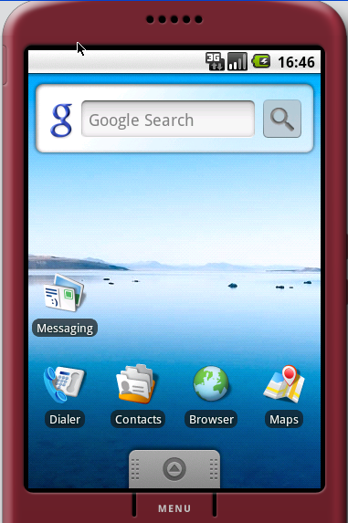
Figure 21–1. Android home page
If you long-click this home page, you will see its context menu (see Figure 21–2).
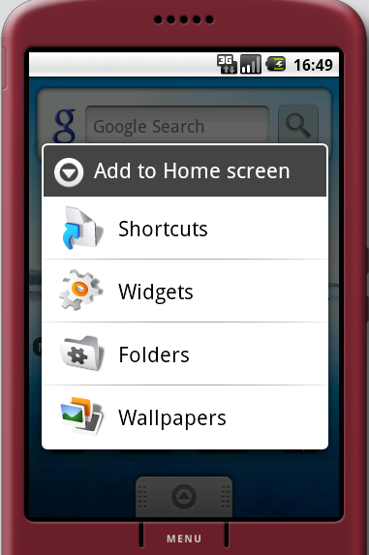
Figure 21–2. Context menu on the Android home page
If you click the Folders option, Android will open another menu showing the live folders that are available (see Figure 21–3). We will build a live folder in the next section, but for now, assume that the live folder we want has already been built and is called “New live folder” (see Figure 21–3).
Note: If you want to walk through this exercise prior to developing it, you can download the project for this chapter and install it on your emulator. See the “References” section for the URL to download. Also, you need to use the contacts application that come with the SDK and is available on the emulator in order to add a few contacts. Once you download and import the project into Eclipse, run it in the emulator to install it as a live folder. Once it is installed on the emulator, it will show up as an option in Figure 21-3.
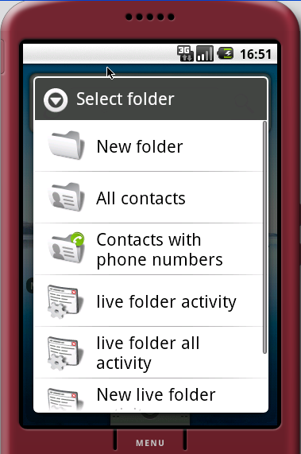
Figure 21–3. Viewing the list of available live folders
If you click the New live folder option, Android creates an icon on the home page representing the live folder. In our example, the name of this folder will be “Contacts LF,” short for “Contacts Live Folder” (see Figure 21–4). This live folder will display contacts from the contacts database. During the implementation of the live folder we will show you how the name “Contacts LF” is specified.
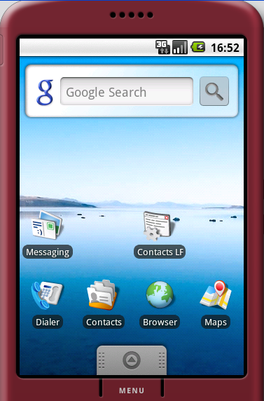
Figure 21–4. The live folder icon on the home page
You will see in the next section that an activity is responsible for creating the Contacts LF folder. For now, as far as the user experience is concerned, you can click the Contacts LF icon to see a list of contacts displayed in a ListView (see Figure 21–5). Again, depending on the release of Android, this list may be presented differently.
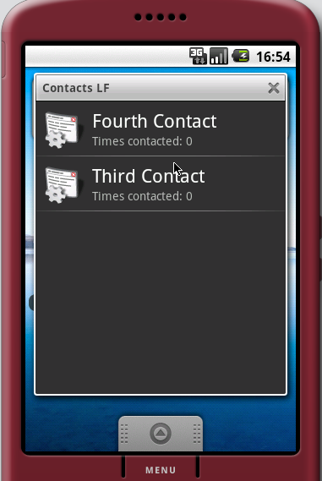
Figure 21–5. Showing live folder contacts
Depending on the number of contacts you have, this list might look different. You can click one of the contacts to display its details (see Figure 21–6). Note that because the details of this contact are presented by the contact application, the appearance is also dependent on the Android release.
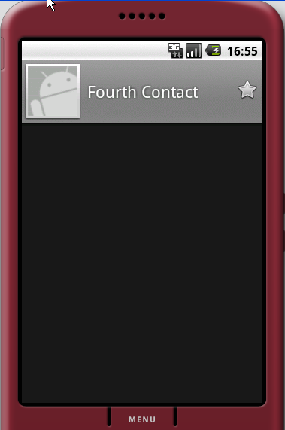
Figure 21–6. Opening a live folder contact
You can click the Menu button at the bottom to see how you can manipulate that individual contact (see Figure 21–7). The options available here are also presented by the contact application. Again, the appearance is release- and device-dependent.
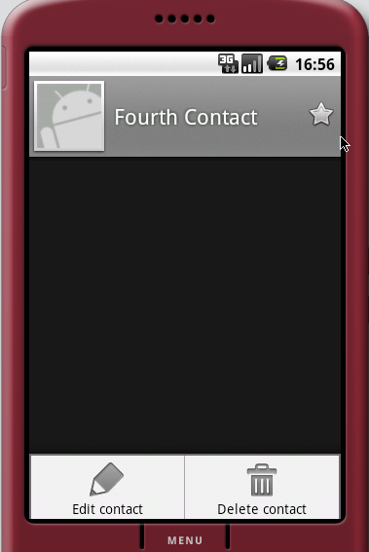
Figure 21–7. Menu options for an individual contact
If you choose to edit the contact, you will see the (release dependent) screen shown in Figure 21–8.
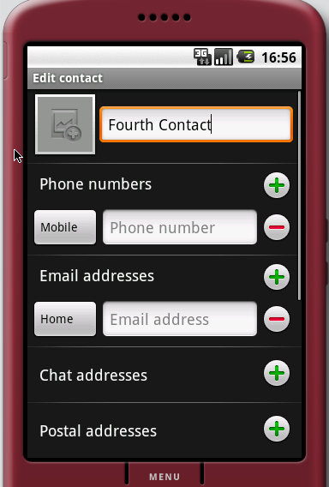
Figure 21–8. Editing contact details
To see the “live” aspect of this live folder, you can update the first name or last name of the contact. Then, when you go back to the live folder view of Contacts LF, you will see those changes reflected. You can do this by clicking the Back button repeatedly until you see the Contacts LF folder.

Building a Live Folder
Now that you know all about live folders and their relevance, we will show you how to build one. To build a live folder, you need two things: an activity and a dedicated content provider. Android uses the label of this activity to populate the list of available live folders, as in Figure 21–3. Android also invokes this activity to get a URI that will be invoked to get a list of rows to display.
The URI supplied by the activity should point to the dedicated content provider that is responsible for returning the rows. The content provider returns these rows through a well-defined cursor. We call the cursor well defined because the cursor is expected to have a known predefined set of column names.
Typically, you package these two entities in an application and then deploy that application onto the device. You will also need some supporting files to make it all work. We will explain and demonstrate these ideas using a sample, which contains the following files:
- AndroidManifest.xml: This file defines which activity needs to be called to create the definition for a live folder.
- AllContactsLiveFolderCreatorActivity.java: This activity is responsible for supplying the definition for a live folder that can display all contacts in the contacts database.
- MyContactsProvider.java: This content provider will respond to the live folder URI that will return a cursor of contacts. This provider internally uses the contacts content provider that ships with Android.
- MyCursor.java: This is a specialized cursor that knows how to perform a requery when underlying data changes.
- BetterCursorWrapper.java: This file is needed by MyCursor to orchestrate the requery.
We’ll describe each of these files to give you a detailed understanding of how live folders work.

AndroidManifest.xml
You’re already familiar with AndroidManifest.xml; it’s the same file that is needed for all Android applications. The live folders section of the file, which is demarcated with a comment, indicates that we have an activity called AllContactsLiveFolderCreatorActivity that is responsible for creating the live folder (see Listing 21–1). This fact is expressed through the declaration of an intent whose action is android.intent.action.CREATE_LIVE_FOLDER.
The label of this activity, “New live folder,” will show up in the context menu of the home page (see Figure 21–3). As we explained in the “How a User Experiences Live Folders” section, you can get to the context menu of the home page by long-clicking the home page.
Listing 21–1. AndroidManifest.xml File for a Live Folder Definition
<?xml version="1.0" encoding="utf-8"?>
<manifest xmlns:android="http://schemas.android.com/apk/res/android"
package="com.androidbook.livefolders"
android:versionCode="1"
android:versionName="1.0">
<application android:icon="@drawable/icon" android:label="@string/app_name">

<!-- LIVE FOLDERS -->
<activity
android:name=".AllContactsLiveFolderCreatorActivity"
android:label="New live folder "
android:icon="@drawable/icon">

<intent-filter>
<action android:name="android.intent.action.CREATE_LIVE_FOLDER" />
<category android:name="android.intent.category.DEFAULT" />
</intent-filter>
</activity>

<provider android:authorities="com.androidbook.livefolders.contacts"
android:multiprocess="true"
android:name=".MyContactsProvider" />

</application>
<uses-sdk android:minSdkVersion="3" />
<uses-permission android:name="android.permission.READ_CONTACTS"/>
</manifest>
Another notable point of the code in Listing 21–1 is the provider declaration, which is anchored at the URI content://com.androidbook.livefolders.contacts and serviced by the provider class MyContactsProvider. This provider is responsible for providing a cursor to populate the ListView that opens when the corresponding live-folder icon is clicked (Figure 21–5). The live folder activity AllContactsLiveFolderCreatorActivity needs to know what this URI is and return it to Android when it is invoked. Android invokes this activity when the live folder name is chosen to create a live folder icon on the home page.
According to the live folder protocol, the CREATE_LIVE_FOLDER intent will allow the home page’s context menu to show the AllContactsLiveFolderCreatorActivity as an option titled “New live folder” (see Figure 21–3). Clicking this menu option will create an icon on the home page, as shown in Figure 21–4.
It is the responsibility of AllContactsLiveFolderCreatorActivity to define this icon, which will consist of an image and a label. In our case, the code in AllContactsLiveFolderCreatorActivity specifies this label as Contacts LF (see Listing 21–2). So let’s take a look at the source code for this live folder creator.

AllContactsLiveFolderCreatorActivity.java
The AllContactsLiveFolderCreatorActivity class has one responsibility: to serve as the generator or creator of a live folder (see Listing 21–2). Think of it as a template for the live folder. Every time this activity is invoked (through the Folders option in the home page’s context menu), it results in a live folder on the home page.
This activity accomplishes its task by telling the invoker—the home page or live folder framework, in this case—the name of the live folder, the image to use for the live folder icon, the URI where the data is available, and the display mode (list or grid). The framework, in turn, is responsible for creating the live folder icon on the home page.
Note: For all the contracts needed by a live folder, see the Android SDK documentation for the android.provider.LiveFolders class.
Listing 21–2. AllContactsLiveFolderCreatorActivity Source Code
public class AllContactsLiveFolderCreatorActivity extends Activity
{
@Override
protected void onCreate(Bundle savedInstanceState)
{
super.onCreate(savedInstanceState);

final Intent intent = getIntent();
final String action = intent.getAction();

if (LiveFolders.ACTION_CREATE_LIVE_FOLDER.equals(action)) {
setResult(RESULT_OK,
createLiveFolder(MyContactsProvider.CONTACTS_URI,
"Contacts LF",
R.drawable.icon)
);
}
else {
setResult(RESULT_CANCELED);
}
finish();
}

private Intent createLiveFolder(Uri uri, String name, int icon)
{
final Intent intent = new Intent();
intent.setData(uri);
intent.putExtra(LiveFolders.EXTRA_LIVE_FOLDER_NAME, name);
intent.putExtra(LiveFolders.EXTRA_LIVE_FOLDER_ICON,
Intent.ShortcutIconResource.fromContext(this, icon));
intent.putExtra(LiveFolders.EXTRA_LIVE_FOLDER_DISPLAY_MODE,
LiveFolders.DISPLAY_MODE_LIST);
return intent;
}
}
The createLiveFolder method essentially sets values on the intent that invoked it. When this intent is returned to the caller, the caller will know the following:
- The live folder name
- The image to use for the live folder icon
- The display mode: list or grid
- The data or content URI to invoke for data
This information is sufficient to create the live folder icon shown in Figure 21–4. When a user clicks this icon, the system will call the URI to retrieve data. It is up to the content provider identified by this URI to provide the standardized cursor. We’ll now show you the code for that content provider: the MyContactsProvider class.

MyContactsProvider.java
MyContactsProvider has the following responsibilities:
- Identify the incoming URI that looks like content://com.androidbook.livefolders.contacts/contacts.
- Make an internal call to the Android-supplied contacts content provider identified by content://contacts/people/. (Pay attention to the Contacts application that came with Android SDK and adjust this URL as it may change with a release.)
- Read every row from the cursor and map it back to a cursor like MatrixCursor with proper column names required by the live folder framework.
- Wrap the MatrixCursor in another cursor so that the requery on this wrapped cursor will make calls to the contacts content provider when needed.
The code for MyContactsProvider is shown in Listing 21–3. Significant items are highlighted based on the responsibilities listed above. The code is explained after the listing.
Listing 21–3. MyContactsProvider Source Code
public class MyContactsProvider extends ContentProvider
{
public static final String AUTHORITY =
"com.androidbook.livefolders.contacts";

//Uri that goes as input to the livefolder creation
public static final Uri CONTACTS_URI =
Uri.parse("content://" + AUTHORITY + "/contacts");

//To distinguish this URI
private static final int TYPE_MY_URI = 0;
private static final UriMatcher URI_MATCHER;
static{
URI_MATCHER = new UriMatcher(UriMatcher.NO_MATCH);
URI_MATCHER.addURI(AUTHORITY, "contacts", TYPE_MY_URI);
}
@Override
public boolean onCreate() {
return true;
}
@Override
public int bulkInsert(Uri arg0, ContentValues[] values) {
return 0; //nothing to insert
}
//Set of columns needed by a LiveFolder
//This is the live folder contract
private static final String[] CURSOR_COLUMNS = new String[]{
BaseColumns._ID,
LiveFolders.NAME,
LiveFolders.DESCRIPTION,
LiveFolders.INTENT,
LiveFolders.ICON_PACKAGE,
LiveFolders.ICON_RESOURCE
};

//In case there are no rows
//use this stand in as an error message
//Notice it has the same set of columns of a live folder
private static final String[] CURSOR_ERROR_COLUMNS = new String[]{
BaseColumns._ID,
LiveFolders.NAME,
LiveFolders.DESCRIPTION
};
//The error message row
private static final Object[] ERROR_MESSAGE_ROW =
new Object[]
{
-1, //id
"No contacts found", //name
"Check your contacts database" //description
};

//The error cursor to use
private static MatrixCursor sErrorCursor =
new MatrixCursor(CURSOR_ERROR_COLUMNS);
static {
sErrorCursor.addRow(ERROR_MESSAGE_ROW);
}

//Columns to be retrieved from the contacts database
private static final String[] CONTACTS_COLUMN_NAMES =
new String[]{
ContactsContract.Contacts._ID,
ContactsContract.Contacts.DISPLAY_NAME,
ContactsContract.Contacts.TIMES_CONTACTED,
ContactsContract.Contacts.STARRED
};

public Cursor query(Uri uri, String[] projection, String selection,
String[] selectionArgs, String sortOrder)
{
//Figure out the uri and return error if not matching
int type = URI_MATCHER.match(uri);
if(type == UriMatcher.NO_MATCH){
return sErrorCursor;
}
Log.i("ss", "query called");
try
{
MatrixCursor mc = loadNewData(this);
mc.setNotificationUri(getContext().getContentResolver(),
Uri.parse("content://contacts/people/"));
MyCursor wmc = new MyCursor(mc,this);
return wmc;
}
catch (Throwable e){
return sErrorCursor;
}
}
public static MatrixCursor loadNewData(ContentProvider cp)
{
MatrixCursor mc = new MatrixCursor(CURSOR_COLUMNS);
Cursor allContacts = null;
try
{
allContacts = cp.getContext().getContentResolver().query(
ContactsContract.Contacts.CONTENT_URI,
CONTACTS_COLUMN_NAMES,
null, //row filter
null,
ContactsContract.Contacts.DISPLAY_NAME); //order by

while(allContacts.moveToNext())
{
String timesContacted = "Times contacted: "+allContacts.getInt(2);
Object[] rowObject = new Object[]
{
allContacts.getLong(0), //id
allContacts.getString(1), //name
timesContacted, //description
Uri.parse("content://contacts/people/"
+allContacts.getLong(0)), //intent
cp.getContext().getPackageName(), //package
R.drawable.icon //icon
};
mc.addRow(rowObject);
}
return mc;
}
finally {
allContacts.close();
}
}
@Override
public String getType(Uri uri)
{
//indicates the MIME type for a given URI
//targeted for this wrapper provider
//This usually looks like
// "vnd.android.cursor.dir/vnd.google.note"
return ContactsContract.Contacts.CONTENT_TYPE;
}

public Uri insert(Uri uri, ContentValues initialValues) {
throw new UnsupportedOperationException(
"no insert as this is just a wrapper");
}
@Override
public int delete(Uri uri, String selection, String[] selectionArgs) {
throw new UnsupportedOperationException(
"no delete as this is just a wrapper");
}
public int update(Uri uri, ContentValues values,
String selection, String[] selectionArgs)
{
throw new UnsupportedOperationException(
"no update as this is just a wrapper");
}
}
Note how the set of columns required by a live folder are initialized in Listing 21–3 and repeated in Listing 21-4 for immediate reference .
Listing 21–4. Columns Needed to Fulfill the Live Folder Contract
private static final String[] CURSOR_COLUMNS = new String[]
{
BaseColumns._ID,
LiveFolders.NAME,
LiveFolders.DESCRIPTION,
LiveFolders.INTENT,
LiveFolders.ICON_PACKAGE,
LiveFolders.ICON_RESOURCE
};
Most of these fields are self-explanatory, except for the INTENT item. If you look at Figure 21–5, you will see that NAME relates to the title of the item in the list. The DESCRIPTION will be underneath the NAME in the same list item.
The INTENT field is actually a string field pointing to the URI of the item in the content provider. Android will use a VIEW action by using this URI when a user clicks on that item. That is why this string field is called an INTENT field, because internally Android will derive the INTENT from the string URI.
The last two fields relate to the icon that is displayed as part of the list. Again, refer to Figure 21–5 to see the icons. Study Listing 21–3 to see how these columns are provided values from the contacts database.
Also note that the MyContactsContentProvider (the wrapper content provider) executes the code from Listing 21–5 to tell the underlying cursor that it needs to watch for any data changes.
Listing 21–5. Registering a URI with a Cursor
MatrixCursor mc = loadNewData(this);
mc.setNotificationUri(getContext().getContentResolver(),
Uri.parse("content://contacts/people/"));
The function loadNewData() retrieves a set of contacts from the contact provider and creates MatrixCursor, which has the columns shown in Listing 21–4. The code then instructs the MatrixCursor to register itself with the ContentResolver so that the ContentResolver can alert the cursor when the data pointed to by the URI (content://contacts/people) changes in any manner.
You should find it interesting that the URI to watch is not the URI of our MyContactsProvider content provider, but the URI of the Android-supplied content provider for contacts. This is because MyContactsProvider is just a wrapper for the “real” content provider. So this cursor needs to watch the underlying content provider instead of the wrapper.
It is also important that we wrap the MatrixCursor in our own cursor, as shown in Listing 21–6.
Listing 21–6. Wrapping a Cursor
MatrixCursor mc = loadNewData(this);
mc.setNotificationUri(getContext().getContentResolver(),
Uri.parse("content://contacts/people/"));
MyCursor wmc = new MyCursor(mc,this);
To understand why we need to wrap the cursor, we need to examine how views operate to update changed content. A content provider, like Contacts, typically tells a cursor that it needs to watch for changes by registering a URI as part of implementing the query method. This is done through cursor.setNotificationUri. The cursor then will register this URI and all its children URIs with the content provider. Then when an insert or delete happens on the content provider, the code for the insert and delete operations needs to raise an event signifying a change to the data in the rows identified by a particular URI.
This will trigger the cursor to get updated via requery, and the view will update accordingly. Unfortunately, the MatrixCursor is not geared for this requery. SQLiteCursor is geared for it, but we can’t use SQLiteCursor here because we’re mapping the columns to a new set of columns.
To accommodate this restriction, we have wrapped the MatrixCursor in a cursor wrapper and overridden the requery method to drop the internal MatrixCursor and create a new one with the updated data. To elaborate further, every time data changes, we want to get a new MatrixCursor. However, to the Android LiveFolder framework we return only the wrapped outer cursor. This will tell the live folder framework that there is only one cursor, but underneath we are coming up with new cursors as data changes.
This is illustrated in the following two classes.

MyCursor.java
Notice how MyCursor is initialized with a MatrixCursor in the beginning (see Listing
21–7). On requery, MyCursor will call back the provider to return a MatrixCursor. Then the new MatrixCursor will replace the old one by using the set method.
Note: We could have done this by overriding the requery of the MatrixCursor, but that class does not provide a way to clear the data and start all over again. So this is a reasonable workaround. (Note that MyCursor extends BetterCursorWrapper, which we’ll discuss next.)
Listing 21–7. MyCursor Source Code
public class MyCursor extends BetterCursorWrapper
{
private ContentProvider mcp = null;

public MyCursor(MatrixCursor mc, ContentProvider inCp)
{
super(mc);
mcp = inCp;
}
public boolean requery()
{
MatrixCursor mc = MyContactsProvider.loadNewData(mcp);
this.setInternalCursor(mc);
return super.requery();
}
}
Now let’s look at the BetterCursorWrapper class to get an idea of how to wrap a cursor.

BetterCursorWrapper.java
The BetterCursorWrapper class (see Listing 21–8) is very similar to the CursorWrapper class in the Android database framework. But we need the BetterCursorWrapper to contain two things that CursorWrapper lacks. First, CursorWrapper doesn’t have a set method to replace the internal cursor from the requery method. Second, CursorWrapper is not a CrossProcessCursor. Live folders need a CrossProcessCursor as opposed to a plain cursor because live folders work across process boundaries.
Listing 21–8. BetterCursorWrapper Source Code
public class BetterCursorWrapper implements CrossProcessCursor
{
//Holds the internal cursor to delegate methods to
protected CrossProcessCursor internalCursor;

//Constructor takes a crossprocesscursor as an input
public BetterCursorWrapper(CrossProcessCursor inCursor)
{
this.setInternalCursor(inCursor);
}

//You can reset in one of the derived class's methods
public void setInternalCursor(CrossProcessCursor inCursor)
{
internalCursor = inCursor;
}

//All delegated methods follow
public void fillWindow(int arg0, CursorWindow arg1) {
internalCursor.fillWindow(arg0, arg1);
}
// ..... other delegated methods
}
We haven’t shown you the entire BetterCursorWrapper class in Listing 21-8, but you can easily use Eclipse to generate the rest of it. Once you have this partial class loaded into Eclipse, place your cursor on the variable named internalCursor. Right-click and choose Source ä Generate Delegated Methods. Eclipse will then populate the rest of the class for you. Once Eclipse generates the delegated methods, you will need to delegate all methods to the internal cursor class as we have done for the fillWindow method in Listing 21-8. (If you don’t want to go through this process, you can see this file in the download project for this chapter.)
Now you have all the classes you need to build, deploy, and run the sample live folder project through Eclipse. Because no activity class is registered as a MAIN category, you won’t see any UI show up when you deploy this project, but you will see a message in the Eclipse console that the project is successfully installed.
Let’s conclude this section on live folders by showing you what happens when you access the live folder.

Exercising Live Folders
Once you have all these files for the live folder project ready, you can build them and deploy them to the emulator. You are now ready to make use of the live folder that we have constructed.
Navigate to the device’s home page; it should look like the screen in Figure 21–1. Follow the steps outlined at the beginning of the “How a User Experiences Live Folders” section. Specifically, locate the live folder you created and create the live folder icon shown in Figure 21–4. Click the Contacts LF live folder icon, and you will see the contact list populated with contacts (Figure 21–5).

Instructions for Compiling the Code
The best way to play around with the code listed in this chapter is to download the ZIP file dedicated for this chapter. The URL for this file is listed in the “References” section. Every class file listed in this chapter is in the downloadable ZIP file.
Unlike a number of projects in this book, this project does not have an activity that gets started when you run it in the emulator. However, you can see in the console of Eclipse that the package is installed successfully.

References
We have found the following resources useful in understanding and working with Live Folders:
- This URL documents the LiveFolders class. http://developer.android.com/reference/android/provider/LiveFolders.html
- This article documents how to use the contacts API. You will need this as the live folder in this chapter uses the contacts underneath. http://developer.android.com/resources/articles/contacts.html
- You can download the test project dedicated for this chapter from www.androidbook.com/projects. The name of the zip file is ProAndroid3_ch21_TestLiveFolders.zip.

Summary
Live folders provide an innovative single-click mechanism to display changing data on the home page. The data can be virtually anything as long as it can be laid out as a set of rows displayed in a list. All the data needs to have is a sense of how to identify and describe itself through name and description. Almost any data element will meet this requirement since most data can be named and described in some manner. It also helps if there is an activity that can display that data when clicked for further details through the live folder. This data can be local, such as contacts, or even Internet-based, such as a summary of blogs.
In this chapter, we have explained the nuances of live folder cursors and what mechanisms you will need to use if you wish to expose already-existing content providers as sources for live folders. We explained the need for cursor wrappers and showed you how to register with a ContentResolver to receive data updates.
In the next chapter, we will introduce you to another home page innovation called
Home Screen Widgets.

