Chapter
23

Android Search
In the last two chapters, 21 and 22, we introduced two home screen-based Android innovations. In Chapter 21, we explained how live folders can reside on the home page and provide quick access to changing data in content providers. In Chapter 22, we explored home screen widgets that provide snapshots of information on the home screen.
Continuing with the theme of information at your fingertips,we will now cover the Android search framework. The Android search framework is extensive. Even though Android search appears to be available only on the home screen of the device, its influence can be extended to activities in your application.
We will start this chapter with a tour of the Android search facility. We will demonstrate global search, search suggestions, suggestion rewriting, and searching the Web. We will show how to include and exclude local applications from participating in global search.
Following the usability tour, we will explore how activities in your applications integrate with the search key. We will work with activities that are not explicitly programmed for search, and we will examine an activity that disables search. We will explore a topic called type-to-search that can be used by activities in applications to invoke search. We will also show you an activity that explicitly invokes search through a menu item.
The key to Android search extensibility is a concept called a suggestion provider. We will explore this concept and write a simple suggestion provider by inheriting from a base suggestion provider available in Android.
However, you often will need to write a custom suggestions provider from scratch. We will discuss this, which will take us to the core of the Android search architecture.
Finally, we will cover two advanced topics and show how you can use action keys available on a device to invoke custom actions using search suggestions. We will also describe how you can pass application-specific data to search when it is invoked. We will conclude the chapter with a list of references.

Android Search Experience
Search capabilities in Android extend the familiar web-based Google search bar to search both device-based local content and Internet-based external content. You can also use this search mechanism to invoke applications directly from the search bar on the home page. Android makes these features possible by providing a search framework that allows local applications to participate.
Android search protocol is simple. It involves a single search box to let users enter search data. This is true whether you are using the global search box on the home page or searching through your own application: you use the same search box.
As the user enters text, Android takes the text and passes it to various applications that have registered to respond to search. Applications will respond by returning a collection of responses. Android aggregates these responses from multiple applications and presents them as a list of possible suggestions.
When the user clicks on one of these responses, Android invokes the application that presented the suggestion. In this sense, Android search is a federated search among a set of participating applications.
Although the overall idea is simple, the details of the search protocol are extensive. We will cover these details through working samples later in this chapter. In this first section, we will explore the search from a user’s perspective.

Exploring Android Global Search
As we explore Android search, although not a prerequisite, we recommend that you also go through the “search” chapter in the Android users guide. We have provided a link to the latest online Android users guide in the references section.
Note: As we were writing the book the Android releases went from 2.0 to 2.2 to 2.3 and 3.0. With each release, although the underlying API hasn’t changed, the UI experience has changed slightly. The screen shots here in this chapter are from 2.2 emulator. Although we have tested the code on 2.3 and 3.0, we haven’t replicated the screenshots from those releases. Where applicable we have indicated the differences in text. Depending on the Android release you have, it should not be too hard to figure out the equivalent UI functionality. Take search settings for example. In each release the place to invoke the search settings screen has changed. But the search settings screen looks the same. So we appreciate if you can keep this discrepancy in mind as you go through this chapter.
You can’t miss search on an Android device; it is usually displayed on the home page, as shown in Figure 23–1. This search box is also referred to as the Quick Search Box (QSB). In some releases of Android, or depending on the device manufacturer/carrier, one may not see this search box by default on the home screen. However, you are sure to see the QSB if you click the search button on the device. Or in devices that don’t have physical keys (such as tablets), you may see yet another obvious mechanism to invoke QSB. Do check with the user guide or manual for that version of Android.
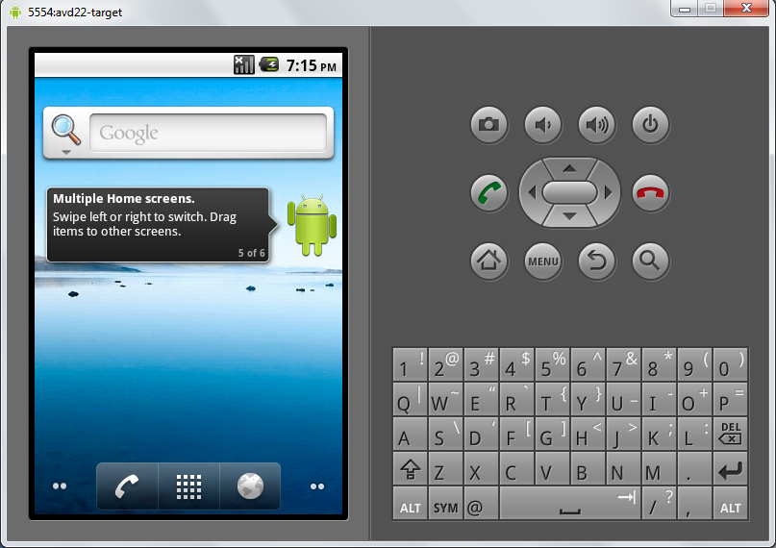
Figure 23–1. Android home page with QSB widget and key pad
Because QSB is implemented as a widget (see to Chapter 22 for more on widgets) you can drag and drop the search widget on to the home screen if it is not already on the home page. You can also remove the QSB from the home page by dragging it to the trash can. Of course you can redrag it from the widgets screen again.
You can directly type into the QSB to start your search. An interesting side effect of QSB being a widget is that shifting focus to the QSB on the home page will basically launch you into global search activity (see Figure 23–2), whereby you leave the home page context. Figure 23–2 is captured in Android release 2.2. It looks identical in Android release 2.3.

Figure 23–2. Global search activity spawned off from the Home search widget
As indicated you can also invoke the search by clicking on the Search action key. Action keys are the set of buttons that are shown in Figure 23–1 on the right hand side. The search key in the set is indicated by the magnifying glass.
Much like the HOME key, you can click the search key any time, irrespective of the application that is visible. However, when an application is in focus there is an opportunity for the application to specialize the search, which we will go into later. This customized search is called a local search. The more general, common, and non-customized search is called a global search.
Note: When the search key is pressed when an application is in focus, it is up to the application to allow or disallow both local and global searches. In releases prior to 2.0 the default action is to allow the global search. In releases 2.2 and 2.3 the default behavior is to disable global search. This means when an activity is in focus the user has to click the home key first and then click the search key.
Prior to release 2.2, Android global search box did not distinguish between individual search suggestion providers (or search applications). Starting in 2.2, Android Search allows you to pick a particular search context (synonymous with a suggestion provider). You can do this by clicking the left hand side icon of the QSB. This will open up a selection of the individual search applications that are providing searches. This is shown in Figure 23–3 for Android release 2.2. For Android release 2.3, this view is very slightly different — a small search settings icon is introduced on the right hand top portion of the expanded search categories section.

Figure 23–3. Global QSB with various application search contexts
This is the default set of search applications (or contexts or search types or suggestion providers) that come with the emulator as of release 2.2 and 2.3. This list may vary with subsequent releases. The search context All behaves much like the global search of prior releases.
You can also create your own search context by coding search suggestion providers and local search activities. We will cover this as we work through the samples in this chapter.

Let’s focus on the search context that is indicated by “all” (represented by the magnifying glass icon). You give focus to QSB (Figure 23–1) either by directly clicking on the QSB or by clicking on the search key. Do not type anything in the QSB yet. At this point, Android will display a screen that may look like Figure 23–2.
Depending on your usage of the device in the past, the image shown in Figure 23–2 may vary, since Android guesses what you are searching for based on past actions. This search mode, when there is no text entered in the QSB, is called zero suggestions mode.
Depending on the search text that is entered, Android will provide a number of suggestions to the user. These suggestions show up below the QSB as a list. These are often called search suggestions. As you type each letter, Android will dynamically replace the search suggestions. When there is no search text, Android will display what are called zero suggestions. In Figure 23–2, Android has determined that Settings is an application the user has used before and that it is a suitable suggestion to present even though no search text has been entered. Although we haven’t typed anything in the QSB, Android also shows the “soft keyboard” in anticipation of an entry. This soft keyboard is also shown in Figure 23–2.
When we type a in the QSB, Android looks for suggestions that start with “a” or related to “a”. You will see that Android has already searched for local installed applications that start with “a” and a number of other search suggestions.
Now we’ll use the down arrow button to highlight the first suggestion. Figure 23–4 shows the view.
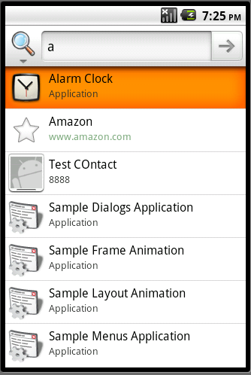
Figure 23–4. Search suggestions
Notice that the first suggestion is highlighted and the focus has shifted from QSB to the first highlighted suggestion. Click the arrow on the right side of the QSB to proceed with the search. Android also expanded the screen to full screen by removing the soft keyboard, because you will not be typing when you navigate. The expanded screen size shows you more suggestions as well.
But let’s look at suggestions one more time. Android takes the search text that has been typed so far and looks for what are called suggestion providers. Android calls each suggestion provider asynchronously to retrieve a set of matching suggestions as a set of rows. Android expects that these rows (called search suggestions) conform to a set of predefined columns (suggestion columns). By exploring these well-known columns, Android will paint the suggestion list. When the search text changes, Android repeats the process all over again. This interaction of calling all suggestion providers for search suggestions is true for the “search all” context. However, if you were to choose a specific search application context from Figure 23–3 only the suggestion provider that is defined for that application will be invoked to retrieve search suggestions.
Note: The set of search suggestions is also called the suggestions cursor. This is because the content provider representing the suggestion provider returns a cursor object.
At this point, if you were to navigate back to the QSB, Android would bring back the soft keyboard. Another thing to notice in Figure 23–4 is the relationship between the highlighted suggestion and the search text in the QSB. The search text remains “a” even though the highlighted suggestion is pointing to a specific item such as the Alarm Clock application. This is not always the case, however, as you can see in Figure 23–5, where we have navigated to a suggestion entry pointing Amazon.
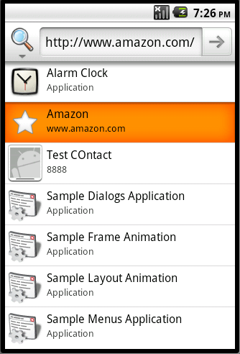
Figure 23–5. Suggestion rewriting
Notice how the search text “a” is replaced by a whole URL representing Amazon. Now you can either click on the arrow (which we’ll call the Go Arrow) to go to Amazon, or simply click on the highlighted suggestion. Both have the same result.
Note: This process of modifying the search text based on the highlighted suggestion is called suggestion rewriting.
We will talk about suggestion rewriting in greater detail a bit later, but briefly, Android uses one of the columns in the suggestion cursor to look for this text. If that column exists, it will rewrite the search text; otherwise it will leave the entered search text as it is.
When a suggestion is not rewritten, there are two possibilities. If you click the Go Arrow icon in the QSB it will search Google for that search text irrespective of what is highlighted. If you click the suggestion item directly it will call an activity called a search activity in the application that put up the suggestion to begin with. This search activity is then responsible for displaying the results of the search.
Figure 23–6 is an example of directly invoking a suggestion. In this example, the suggestion is an application called Alarm Clock. When you click it, Android will invoke that application directly. How this actually happens is a bit involved, and we will go through later in this chapter (see the section “Implementing a Custom Suggestions Provider”).
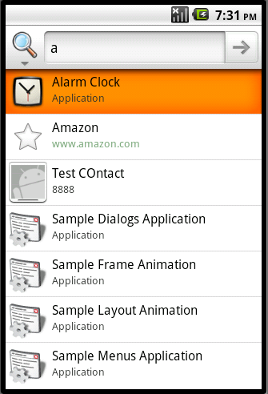
Figure 23–6. Invoking an application through Search
Figure 23–7 shows what happens if you click the Go Arrow when your search text is “a.”
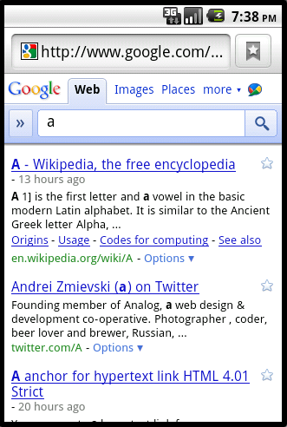
Figure 23–7. Searching the Web
Now that you are familiar with using the QSB for your searching needs, in the next part of our tour we will explain how to enable or disable specific applications from participating in global search.

Enabling Suggestion Providers for Global Search
As we have already pointed out, applications use suggestion providers to respond to searches. Just because your application has the infrastructure necessary to respond to searches doesn’t mean your suggestions will show up in the QSB automatically. A user will need to explicitly allow your suggestion provider to participate. We will now walk you through the process of enabling or disabling available suggestion providers. The way you get to the settings that follow is slightly different between Android releases 2.2 and 2.3. We will cover 2.2 first.

Working with Search Settings in Android Release 2.2
Let’s start with the screen that will take us to the Android settings (Figure 23–8).
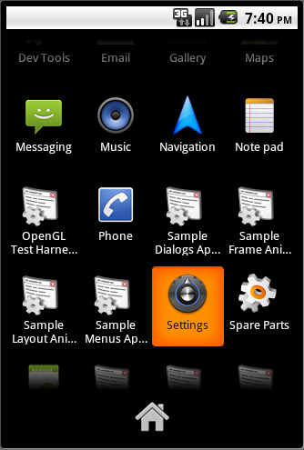
Figure 23–8. Locating the settings application
You can reach this view by clicking on the List of Applications icon at the bottom of the device screen (see Figure 23–1 for the home screen). Use your arrow down key to navigate to the application that is named Settings, as shown in Figure 23–8. This will take you to the Android settings page, which looks like Figure 23–9.
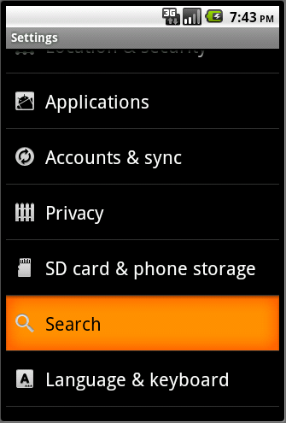
Figure 23–9. Getting to the settings of the Searc” application
Among the many Android settings, choose the Search (Manage search settings and history) option. This will bring you to the Search settings application shown in Figure 23–10.
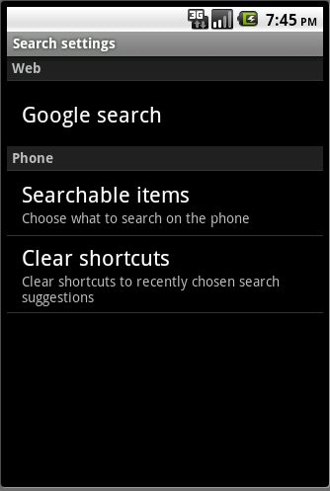
Figure 23–10. Search settings application
In this activity, look for the tab called Quick Search Box and choose Searchable items (Choose what to search on the phone). This will show a list of available suggestion providers (sometimes also referred as search applications), as shown in Figure 23–11. Again this list may vary from release to release.
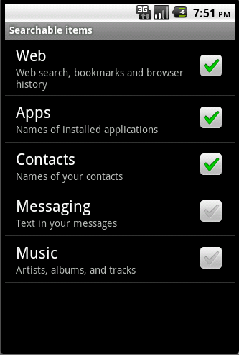
Figure 23–11. Enabled/disabled search applications

Suggestion providers (or the applications of which they are a part) that are included in global search are selected in Figure 23–11. By default, a new suggestion provider or search application is not selected. You can click on a suggestion provider to enable it for search. When it is enabled this suggestion provider will offer suggestions to the global search. The enabled suggestion provider will also show up in the list of searchable applications in Figure 23–3.

Working with Search Settings in Android Release 2.3

When you are looking to discover suggestion provider settings the difference between Android releases 2.2 and 2.3 (and hopefully future a future phone SDK release) is how you get to the search settings screen of Figure 23–10 or 23–11.

In Android release 2.3 you can directly reach figure 23–11 from the expanded search categories screen of Figure 23–2. In Android release 2.3 this figure 23–2 has a small settings icon on it. If you click this icon you will be directly taken to Figure 23–11 where you will see your custom search activities.

To get to the general search settings screen of Figure 23–10 you will need to revisit screen of Figure 23–2 or 23–3 or 23–4. Essentially you clicked on QSB. While the focus is with the QSB if you click the Menu button you will see a menu item called “Search Settings.” If you click this menu item you will be taken to the general search settings of Figure 23–10. Once you are at this screen the instructions to work with the settings are same as those for Android release 2.2.
So far, we’ve given you a high-level view of how search works in Android. Next we will explore these ideas further and show you how all this works through examples. We’ll start by exploring how simple activities interact with search.

Activities and Search Key Interaction
What happens when a user clicks on the search key when an activity is in focus? The answer depends on the type of activity that is in focus. We will explore behavior for the following types of activities:
- A regular activity that is unaware of search
- An activity that explicitly disables search
- An activity that invokes global search explicitly
- An activity that specifies a local search
We will explore these options by a working sample containing the following files (after going through each of them we will show you the screens from this application to demonstrate the concepts).

The primary Java files are
- RegularActivity.java (Listing 23–1)
- NoSearchActivity.java (Listing 23–6)
- SearchInvokerActivity.java (Listing 23–8)
- LocalSearchEnabledActivity.java (Listing 23–13)
- SearchActivity.java (Listing 23–11)
Each of these files, except the last one (SearchActivity.java), represents each type of activity that we want to examine as mentioned above. The last file, SearchActivity.java, is needed by the LocalSearchEnabledActivity. Each of these activities, including the SearchActivity has a simple layout with a text view in it. Each is supported by the following layout files:
- res/layout/main.xml (for the RegularActivity) (Listing 23–3)
- res/layout/no_search_activity.xml Listing 23–7)
- res/layout/search_invoker_activity.xml (Listing 23–9)
- res/layout/local_search_enabled_activity.xml (Listing 23–14)
- res/layout/search_activity.xml (part of listing 23–11)
The following two files define these activities to Android and also search metadata for the one local search activity:
- AndroidManifest.xml (Listing 23–2)
- xml/searchable.xml (Listing 23–12)
The following file contains the text commentary for each of the layouts:
- res/values/strings.xml (Listing 23–4)
The following two menu files provide menus needed to invoke the activities and also global search where needed:
- res/menu/main_menu.xml (Listing 23–5)
- res/menu/search_invoker_menu.xml (Listing 23–10)
We will now explore the interaction between activities and the search key by methodically walking through the source code of these files by each activity type.
Note: If you would like to compile and test these files, we recommend you to download the importable Eclipse projects for this chapter from the URL provided at the end of this chapter.
Let us start to explore the behavior of search key in the presence of a regular Android activity.

Behavior of Search Key on a Regular Activity
To test what happens when an activity that is unaware of search is in focus we’ll show you an example of a regular activity. Listing 23–1 shows the java source code representing this RegularActivity.
Listing 23–1. Regular Activity Source Code
//filename: RegularActivity.java
public class RegularActivity extends Activity
{
private final String tag = "RegularActivity";

@Override
public void onCreate(Bundle savedInstanceState) {
super.onCreate(savedInstanceState);
setContentView(R.layout.main);
}

@Override
public boolean onCreateOptionsMenu(Menu menu)
{
//call the parent to attach any system level menus
super.onCreateOptionsMenu(menu);

MenuInflater inflater = getMenuInflater();

//getMenuInflater() is from base activity

inflater.inflate(R.menu.main_menu, menu);
return true;
}

@Override
public boolean onOptionsItemSelected(MenuItem item)
{
appendMenuItemText(item);
if (item.getItemId() == R.id.menu_clear) {
this.emptyText();
return true;
}

if (item.getItemId() == R.id.mid_no_search) {
this.invokeNoSearchActivity();
return true;
}
if (item.getItemId() == R.id.mid_local_search) {
this.invokeLocalSearchActivity();
return true;
}
if (item.getItemId() == R.id.mid_invoke_search) {
this.invokeSearchInvokerActivity();
return true;
}
return true;
}

private TextView getTextView()
{
return (TextView)this.findViewById(R.id.text1);
}

private void appendMenuItemText(MenuItem menuItem)
{
String title = menuItem.getTitle().toString();
TextView tv = getTextView();
tv.setText(tv.getText() + "\n" + title);
}
private void emptyText()
{
TextView tv = getTextView();
tv.setText("");
}
private void invokeNoSearchActivity()
{
//Uncomment the following two lines when you
//you add this activity to your project

//Intent intent =
// new Intent(this,NoSearchActivity.class);
//startActivity(intent);
}
private void invokeSearchInvokerActivity()
{
//Uncomment the following two lines when you
//you add this activity to your project

//Intent intent =
// new Intent(this,SearchInvokerActivity.class);
//startActivity(intent);
}
private void invokeLocalSearchActivity()
{
//Uncomment the following two lines when you
//you add this activity to your project

//Intent intent =
// new Intent(this,LocalSearchEnabledActivity.class);
//startActivity(intent);
}
}
The goal of this activity is to play the role of a simple activity that is unaware of search. In this example, however, this activity also works as the driver to invoke other activity types that we would like to test. This is why you see some menu items being introduced to represent these additional activities. Each function that starts with invoke... has code to start the other type of activities that we want to test.
We will present the necessary files to compile this code in quick order. However, you may want to comment out the “invoke…” functions or include listings for those classes as well at this time. For your benefit we have already commented out these lines.
Let us take a look at the manifest file to see how this activity is defined (see Listing 23–2). You can also see the definition of other activities here, although they will not be explained until later. Again we have commented out those additional activities until a later time when they are needed.
Listing 23–2. Activity/Search Key Interaction: Manifest file
//filename: AndroidManifest.xml

<manifest

xmlns:android="http://schemas.android.com/apk/res/android"
package="com.androidbook.search.nosearch">

<application android:icon="@drawable/icon"
android:label="Test Activity QSB Interaction">
<activity android:name=".RegularActivity"
android:label="Activity/QSB Interaction:Regular Activity">
<intent-filter>
<action android:name="android.intent.action.MAIN" />
<category android:name="android.intent.category.LAUNCHER" />
</intent-filter>
</activity>

<!-- Uncomment the following activities as you create them.
We will indicate when you need to uncomment each activity

<activity android:name=".NoSearchActivity"
android:label="Activity/QSB Interaction::Disabled Search">
</activity>

<activity android:name=".SearchInvokerActivity"
android:label="Activity/QSB Interaction::Search Invoker">
</activity>

<activity android:name=".LocalSearchEnabledActivity"
android:label="Activity/QSB Interaction::Local Search">
<meta-data android:name="android.app.default_searchable"
android:value=".SearchActivity" />
</activity>

<activity android:name=".SearchActivity"
android:label="Activity/QSB Interaction::Search Results">

<intent-filter>
<action android:name="android.intent.action.SEARCH"/>
<category android:name="android.intent.category.DEFAULT"/>

</intent-filter>
<meta-data android:name="android.app.searchable"
android:resource="@xml/searchable" />

</activity>

-->
</application>
<uses-sdk android:minSdkVersion="4" />
</manifest>
Notice that the RegularActivity is defined as the main activity for this project and has no other characteristics related to search.
The layout file for this activity is shown in Listing 23–3.
Listing 23–3. Regular Activity Layout File
//filename: layout/main.xml
<?xml version="1.0" encoding="utf-8"?>
<LinearLayout
xmlns:android="http://schemas.android.com/apk/res/android"
android:orientation="vertical"
android:layout_width="fill_parent"
android:layout_height="fill_parent"
>
<TextView
android:id="@+id/text1"
android:layout_width="fill_parent"
android:layout_height="wrap_content"
android:text="@string/regular_activity_prompt"
/>
</LinearLayout>
Now we’ll show you the string resources used by this project. Listing 23–4 contains string resources for other activities of this project as well. However, these additional string resources should not interfere with compilation of the current activity, even if you haven’t introduced the other activities.
With that, Listing 23–4 shows the strings.xml that is responsible for the text you will see on this activity’s display. The individual string resources related to each activity are highlighted and commented.
Listing 23–4. Activity/Search Key Interaction: strings.xml
//filename: /res/values/strings.xml
<?xml version="1.0" encoding="utf-8"?>
<resources>
<!--
**************************************************
* regular_activity_prompt
**************************************************
-->
<string name="regular_activity_prompt">

This is a sample application to test how QSB and Search Key
interacts with activities. This application has 4 activities
including this one. The activity you are looking at is
called a Regular Activity and is one of 4. The other three
you can access through the menu.
\n\n
This activity is a regular activity that is unaware of
any search capabilities. If you click search key now
it will NOT invoke the global search.
\n
\nThe other activities demonstrate:`
\n\n1) No search Activity: An activity that disables search

\n2) Invoke search: programatically invoke global search
\n3) Local Search Activity: Invoke Local Search
\n
\nYour debug will appear here
</string>

<!--
**************************************************
* no_search_activity_prompt
**************************************************
-->
<string name="no_search_activity_prompt">
In this activity the onSearchRequested
returns a false. The search button
should be ignored now.
\n
\nYou can click back now to access the
previous activity and use the menus again
to choose other activities.
</string>
<!--
**************************************************
* search_activity_prompt
**************************************************
-->
<string name="search_activity_prompt">
This is called a search activity or search results activity.
This activity is invoked by clicking on the search key when
some other activity uses this activity as its
search results activity.
\n\n
Typically you can retrieve the query string
from the intent to see what the query is.
</string>
<!--
**************************************************
* search_invoker_activity_prompt
**************************************************
-->
<string name="search_invoker_activity_prompt">
In this activity a search menu item is used
to invoke the default search. In this case
as there is no local search for this activity
specified global search is invoked. Use the
menu button to see the "search" menu. when you
click on that search menu you will see the
global search.
</string>
<!--
**************************************************
* local_search_enabled_activity_prompt
**************************************************
-->
<string name="local_search_enabled_activity_prompt">

This is a very simple activity that has indicated through
the manifest file that there is a an associated search
activity. With this association when the search key is
pressed the local search is presented instead of global.
\n\n
You can see the local nature of it by looking at the
label of the QSB and also the hint in the QSB. Both
came from the search metadata.
\n\n
Once you click on the query icon, it will transfer
you to the local search activity.
</string>
<!--
**************************************************
* Other values
**************************************************
-->
<string name="search_label">Local Search Demo</string>

<string name="search_hint">Local Search Demo Hint</string>
</resources>
Like the Android manifest, this single strings.xml is serving all of the activities in this project. You can see that the string constant named regular_activity in the strings.xml is pointing to the text you will see on the regular activity.
To assist the compilation of the regular activity let us present now the menu resource file in Listing 23–5. Although this menu file contains menu items for other activities yet to be introduced, it won’t interfere with compiles and assists in having the regular activity of Listing 23–1 compiled.
Listing 23–5. Regular Activity Menu File

<menu xmlns:android="http://schemas.android.com/apk/res/android">

<!-- filename: /res/menu/main_menu.xml →
<!-- This group uses the default category. -->
<group android:id="@+id/menuGroup_Main">
<item android:id="@+id/mid_no_search"
android:title="No Search Activity" />

<item android:id="@+id/mid_local_search"
android:title="Local Search Activity" />

<item android:id="@+id/mid_invoke_search"
android:title="Search Invoker Activity" />

<item android:id="@+id/menu_clear"
android:title="clear" />

</group>
</menu>
With these files in place, you should be able to compile and test this activity (or you can wait until we have looked at all the activities for this project). If you would like to compile now, you will need to keep the rest of activities commented out in listings 23–1 and 23–2. Or you can use the listings identified at the beginning of this sample to compile the entire application first and then follow along.
When you finish compiling the application and run the main regular activity we introduced, the layout should look like Figure 23–12.
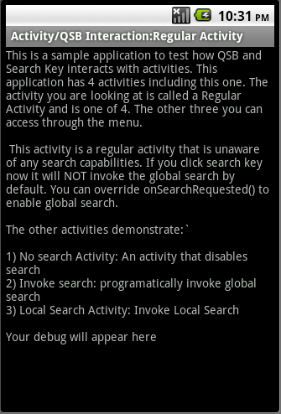
Figure 23–12. Regular activity/search interaction
Listing 23–5 shows the menu XML file that is used for the regular activity. You can see this menu in action in Figure 23–13.
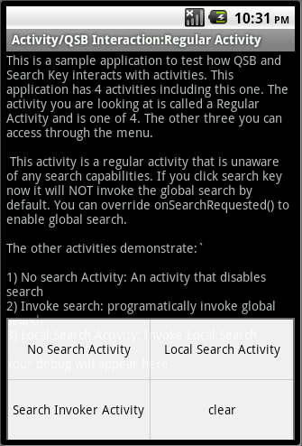
Figure 23–13. Accessing other test activities
Now, when you have this activity running (as in Figure 23–12) click the search key (see Figure 23–1 to locate the search key). The documentation indicates that this should invoke the global search dialog.
In releases prior to 2.0 the search key was bringing the global search in response. In releases 2.2 and 2.3 pressing the search key does not bring up the global search.
If you want to force this regular activity to allow global search instead it needs to override the onSearchRequested() and do the following:
@Override
public boolean onSearchRequested()
{

Log.d(tag,"onsearch request called");
this.startSearch("test",true,null,true);
return true;
}
With this code in place in the ReqularActivity.java, you can press the search key and it will invoke the global search. The method “startSearch()” and its arguments are covered later in the chapter. This global search will look just like the global search in Figure 23-2.

Behavior of an Activity that Disables Search
An activity has the option to entirely disable the search (both global and local) by returning false from the onSearchRequested() callback method of the activity class. Listing 23–6 shows the source code for such an activity, which we named “NoSearchActivity”.
Listing 23–6. Activity-disabling Search
//filename: NoSearchActivity.java
public class NoSearchActivity extends Activity
{
@Override
protected void onCreate(Bundle savedInstanceState) {
super.onCreate(savedInstanceState);
setContentView(R.layout.no_search_activity);
return;
}
@Override
public boolean onSearchRequested()
{
return false;
}
}
Listing 23–7 shows the corresponding layout file for this activity.
Listing 23–7. NoSearchActivity XML File
//filename: layout/no_search_activity.xml
<?xml version="1.0" encoding="utf-8"?>
<LinearLayout
xmlns:android="http://schemas.android.com/apk/res/android"
android:orientation="vertical"
android:layout_width="fill_parent"
android:layout_height="fill_parent"
>
<TextView
android:id="@+id/text1"
android:layout_width="fill_parent"
android:layout_height="wrap_content"
android:text="@string/no_search_activity_prompt"
/>
</LinearLayout>
With these two files in place (Listing 23–6 and 23–7), you need to uncomment a couple sections in the following two files:
RegularActivity.java (Listing 23–1)
AndroidManifest.xml (Listing 23–2)
In the RegularActivity.java file (Listing 23–1), uncomment the java code in the body of the function “invokeNoSearchActivity()”.
In the AndroidManifest.xml (Listing 23–2) uncomment the activity definition for NoSearchActivity. Notice that this is an XML file. How you comment and uncomment an XML file differs from uncommenting Java code.
Once you complete these two uncommenting tasks you will be able to compile the project again. Now you can invoke this NoSearchActivity by clicking the menu item No Search Activity in Figure 23–13.
When displayed, this activity will look like that shown in Figure 23–14. Now if you press the search key, it will not have any impact; you will not see anything happen.

Figure 23–14. Disabled search activity
Tip: When there is an activity that disables search, clicking the search key does not result in the invocation of search both local and global.

Explicitly Invoking Search Through a Menu
In addition to being able to respond to the search key, an activity can also choose to explicitly invoke search through a search menu item. Listing 23–8 shows the source code for an example activity (SearchInvokerActivity) that does this.
Listing 23–8. SearchInvokerActivity
//filename: SearchInvokerActivity.java
public class SearchInvokerActivity extends Activity
{
@Override
public void onCreate(Bundle savedInstanceState) {
super.onCreate(savedInstanceState);
setContentView(R.layout.search_invoker_activity);
}

@Override
public boolean onCreateOptionsMenu(Menu menu)
{
super.onCreateOptionsMenu(menu);
MenuInflater inflater = getMenuInflater();
inflater.inflate(R.menu.search_invoker_menu, menu);
return true;
}

@Override
public boolean onOptionsItemSelected(MenuItem item)
{
appendMenuItemText(item);
if (item.getItemId() == R.id.mid_si_clear)
{
this.emptyText();
return true;
}
if (item.getItemId() == R.id.mid_si_search)
{
this.invokeSearch();
return true;
}
return true;
}

private TextView getTextView()
{
return (TextView)this.findViewById(R.id.text1);
}

private void appendMenuItemText(MenuItem menuItem)
{
String title = menuItem.getTitle().toString();
TextView tv = getTextView();
tv.setText(tv.getText() + "\n" + title);
}
private void emptyText()
{
TextView tv = getTextView();
tv.setText("");
}
private void invokeSearch()
{
this.onSearchRequested();
}
@Override
public boolean onSearchRequested()
{
this.startSearch("test",true,null,true);
return true;
}
}
Key portions of source code are highlighted in bold. Notice how a menu ID (R.id.mid_si_search) is calling the function invokeSearch, which will in turn call the onSearchRequested(). This method, onSearchRequested(), invokes the search.
The base method “startSearch” has the following arguments
initialQuery: Text to search for.
selectInitialQuery: A boolean indicating whether to highlight the search text or not. In this case we used “true” to hightlight the text so that it can deleted in favor of a new text if desired.
appSearchData: A bundle object to pass to the search activity. In our case, we are not targeting any particular search activity we passed null.
globalSearch: If it is true, the global search is invoked. If it is false, a local search is invoked if available; otherwise a global search is invoked.
SDK documentation recommends to call the base onSearchRequested() unlike what we have shown in Listing 23–8. However, the default onSearchRequested() is using false for the last argument of startSearch(). According to the documentation this should invoke the global search if no local search is available. However, in this release (both 2.2 and 2.3) the global search is not being invoked. This could either be a bug or designed that way and requiring a documentation update.
In this example we have forced a global search by passing true to this last argument of startSearch().
Listing 23–9 shows the layout for this activity.
Listing 23–9. SearchInvokerActivity XML
//filename: layout/search_invoker_activity.xml
<?xml version="1.0" encoding="utf-8"?>
<LinearLayout
xmlns:android="http://schemas.android.com/apk/res/android"
android:orientation="vertical"
android:layout_width="fill_parent"
android:layout_height="fill_parent"
>
<TextView
android:id="@+id/text1"
android:layout_width="fill_parent"
android:layout_height="wrap_content"
android:text="@string/search_invoker_activity_prompt"
/>
</LinearLayout>
Listing 23–10 shows the corresponding menu XML for this activity.
Listing 23–10. SearchInvokerActivity Menu XML
//filename:menu/search_invoker_menu.xml

<menu xmlns:android="http://schemas.android.com/apk/res/android">
<!-- This group uses the default category. -->
<group android:id="@+id/menuGroup_Main">
<item android:id="@+id/mid_si_search"
android:title="Search" />

<item android:id="@+id/mid_si_clear"
android:title="clear" />

</group>
</menu>
With these three files in place (Listing 23–8, 23–9, 23–10) you need to uncomment a couple sections in the following two files:
RegularActivity.java (Listing 23–1)
AndroidManifest.xml (Listing 23–2)
In the RegularActivity.java file (Listing 23–1) uncomment the java code in the body of the function “invokeSearchInvokerActivity().”
In the AndroidManifest.xml (Listing 23–2) uncomment the activity definition for SearchInvokerActivity. Once you complete these two uncommenting tasks you will be able to compile the project again.
With the layout and menu in place, Figure 23–15 shows how this activity looks when invoked from the main menu on the RegularActivity (see Figure 23–13 for the menu item Search Invoker Activity that invokes this).
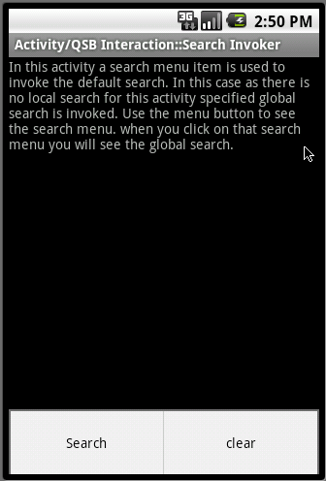
Figure 23–15. Search invoker activity
From this activity, if you click the Search menu option it will invoke the familiar global search QSB, as shown in Figure 23–2. As we have also overridden the “onSearchRequested()” from the base activity, the device Search Key will bring up the global QSB as well.

Understanding Local Search and Related Activities
Now let’s look at the circumstances under which the search key will not invoke a global search, but instead invoke a local search. But first, we have to explain local search a bit further.
A local search has three components. The first component is a search box that is very similar, if not the same, as the global search QSB. This QSB, whether local or global, provides text control to enter text and a search icon to click. A local QSB is typically invoked instead of the global one when an activity declares in the manifest file that it wants a local search. You can distinguish the invoked local QSB from the global one by looking at the heading of the QSB (see the title of a future Figure 23–18) and the hint (the text inside the search box) in the QSB. These two values, as you will see, come from a search metadata XML file.
The second component of local search is an activity that can receive the search string from the local QSB and show a set of results or any output that is related to the search text. Often this activity is called the search activity or search results activity.
The optional third component of local search is an activity that is allowed to invoke the search results activity just described (the second component). This invoking activity is often called search invoker or search invoking activity. This search invoker activity is optional because it is possible to have the global search directly invoke the local search activity (the second component) through a suggestion.
You can see these three components and how they interact with each other in context in Figure 23–16.
Figure 23–16. Local search activity interaction
In Figure 23–16 important interactions are shown as annotated (circled numbers) arrows. Here’s a more detailed explanation:
- A SearchActivity needs to be defined in the manifest file as an activity that is capable of receiving search requests. SearchActivity also uses a mandatory XML file to declare how the local QSB should be presented (such as with a title, hint, and so on) and if there is an associated suggestion provider. (See Listing 23–12). In Figure 23–16 you can see this as a couple of “Definition” lines that go between the SearchActivity and the two XML files (manifest file and the search metadata file).
- Once the SearchActivity is defined in the manifest file (see Listing 23–2), the Search InvokingActivity indicates in the manifest file that it is associated with the SearchActivity through a metadata definition android.app.default_searchable.
- With the definitions for both activities in place, when the SearchInvokingActivity is in focus, the press of the search key will invoke the local QSB. You can see this in Figure 23–16 – the circles numbered 1 and 2. You can tell that the invoked QSB is a local QSB by looking at the caption and hint of the QSB. These two values are set up in the mandatory search metadata XML definition. Once QSB is invoked through the search key, you will be able to type query text in the QSB. This local QSB, similar to the global QSB, is capable of suggestions. You can see this in Figure 23–16 (circle 3).
- Once the query text is entered and the search icon is clicked, the local QSB will transfer the search to the SearchActivity which is responsible for doing something with it, such as displaying a set of results. This is shown in Figure 23–16 (circle 4).
We will examine each of these interactions by looking at the source code. We will start with Listing 23–11, the source code for SearchActivity, (which, again, is responsible for receiving the query and displaying search results).
Listing 23–11. SearchActivity and Its Layout File
//filename: SearchActivity.java
public class SearchActivity extends Activity
{
@Override
protected void onCreate(Bundle savedInstanceState) {
super.onCreate(savedInstanceState);
setContentView(R.layout.search_activity);
return;
}
}

//And the corresponding res/layout/search_activity.xml

<?xml version="1.0" encoding="utf-8"?>
<LinearLayout
xmlns:android="http://schemas.android.com/apk/res/android"
android:orientation="vertical"
android:layout_width="fill_parent"
android:layout_height="fill_parent"
>
<TextView
android:id="@+id/text1"
android:layout_width="fill_parent"
android:layout_height="wrap_content"
android:text="@string/search_activity_prompt"
/>
</LinearLayout>
We took a simplest possible search activity. Later you’ll see how queries are retrieved by this activity. For now we will show how this activity ends up being invoked by the QSB. Here is how it is defined as a search activity responsible for results in the manifest file (see Listing 23–2):

<activity android:name=".SearchActivity"
android:label="Activity/QSB Interaction::Search Results">

<intent-filter>
<action android:name="android.intent.action.SEARCH"/>

<category android:name="android.intent.category.DEFAULT"/>
</intent-filter>
<meta-data android:name="android.app.searchable"
android:resource="@xml/searchable"/>

</activity>
Note: There are two things that need to be specified for a search activity. The activity needs to indicate that it can respond to SEARCH actions. It also needs to specify an xml file that describes the metadata that is required to interact with this search activity.
Listing 23–12 shows the search metadata XML file for this SearchActivity.
Listing 23–12. Searchable.xml: Search Metadata
<!-- /res/xml/searchable.xml -->
<searchable xmlns:android="http://schemas.android.com/apk/res/android"
android:label="@string/search_label"
android:hint="@string/search_hint"
android:searchMode="showSearchLabelAsBadge"
/>
Tip: The various options available in this XML are documented in the SDK at http://developer.android.com/reference/android/app/SearchManager.html.
We will cover more of these attributes later in the chapter. For now, the attribute android:label is used to label the search box. The attribute android:hint is used to place the text in the search box, similar to what’s shown in Figure 23–18.
Now let’s examine how an activity can specify this SearchActivity as its search. We will call this the LocalSearchEnabledActivity. Listing 23–13 shows the source code for this activity.
Listing 23–13. LocalSearchEnabledActivity
//filename: LocalSearchEnabledActivity.java
public class LocalSearchEnabledActivity extends Activity
{
@Override
protected void onCreate(Bundle savedInstanceState) {
super.onCreate(savedInstanceState);
setContentView(R.layout.local_search_enabled_activity);
return;
}
}
Listing 23–14 shows the corresponding layout xml file for this activity.
Listing 23–14. LocalSearchEnabledActivity Layout File
<?xml version="1.0" encoding="utf-8"?>
<!-- filename: layout/local_search_enabled_activity.xml -->
<LinearLayout
xmlns:android="http://schemas.android.com/apk/res/android"
android:orientation="vertical"
android:layout_width="fill_parent"
android:layout_height="fill_parent"
>
<TextView
android:id="@+id/text1"
android:layout_width="fill_parent"
android:layout_height="wrap_content"
android:text="@string/local_search_enabled_activity_prompt"
/>
</LinearLayout>
Also notice how this LocalSearchEnabledActivity (Listing 23–13) is targeting the SearchActivity (Listing 23–11) as its target search activity. You can uncover this relationship by looking at the manifest file definition (Listing 23–2) for the LocalSearchEnabledActivity. Here is that definition replicated for quick browsing:
<activity android:name=".LocalSearchEnabledActivity"
android:label="Activity/QSB Interaction::Local Search">
<meta-data android:name="android.app.default_searchable"
android:value=".SearchActivity" />
</activity>
It is time to review what new files we have presented so far so that you can test these two activities: LocalSearchEnabledActivity and the SearchActivity. These new files and their listing numbers are:
SearchActivity.java (Listing 23–11)
layoyut/search_activity.xml (presented as part of Listing 23–11)
res/xml/searchable.xml (Listing 23–12)
LocalSearchEnabledActivity.java (Listing 23–13)
local_search_enabled_activity (Listing 23–14)
With these files in place, you need to uncomment a couple sections in the following two files:
RegularActivity.java (Listing 23–1)
AndroidManifest.xml (Listing 23–2)
In the RegularActivity.java file (Listing 23–1) uncomment the java code in the body of the function “invokeLocalSearchActivity().”
In the AndroidManifest.xml (Listing 23–2) uncomment the activity definition for LocalSearchEanabledActivity and SearchActivity.
Once you complete these two uncommenting tasks, you will be able to compile the project again.
With these new activities and their layouts in place, you can invoke this LocalSearchEnabledActivity from the main RegularActivity by clicking the Local Search Activity menu item (see Figure 23–13 to locate the menus). When invoked, this activity looks like Figure 23–17.
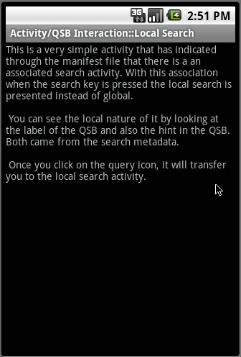
Figure 23–17. Local search-enabled activity
With this activity in focus, if you click on the device search it will invoke a local search box (local QSB), as shown in Figure 23–18.
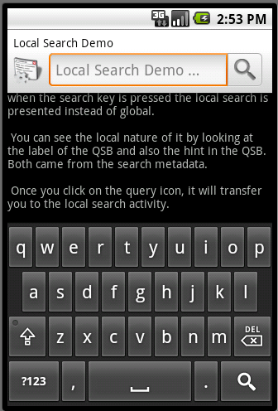
Figure 23–18. Local Search QSB
Notice the label of this search box and the hint of this search box. See how they differ from the global search (see Figure 23–2). The label and hint came from the search metadata (searchable.xml Listing 23–12) specified for the SearchActivity. Now if you type text in the QSB and click the search icon you will end up invoking the SearchActivity (see Listing 23–11). Here is what this SearchActivity looks like
(Figure 23–19).
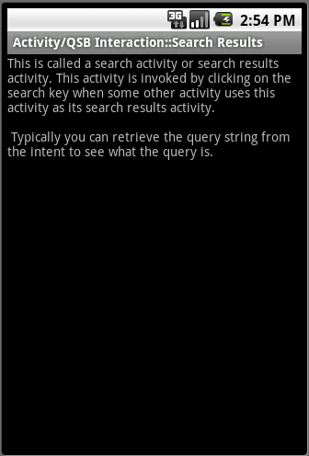
Figure 23–19. Search results in response to the local search QSB
Although this activity does not make use of any query search text to pull up results, it demonstrates how a search activity is defined and gets invoked. Later in the chapter we’ll show how this SearchActivity makes use of search queries and various search-related actions to which it needs to respond.

Enabling Type-to-Search
So far we have explored a few ways of invoking search, both local and global. We have showed you how to search using QSB on the home page of the device. We have told you how to invoke global search from any activity as long as the activity doesn’t prevent such a search. We have also showed you how an activity can specify local search. We will close this topic by showing one more way of invoking search called type-to-search.
When you are looking at an activity such as the RegularActivity shown in Figure 23–12 there is a way to invoke search by typing a random letter (such as “t,” for example). This mode is called type-to-search because any key you type that is not handled by the activity will invoke search.
The intention of type-to-search is this. On any Android activity you can tell Android that any key press can invoke search—except for the keys that the activity explicitly handles. For example, if an activity handles “x” and “y” but doesn’t care about any other keys, the activity can choose to invoke the search for any other keys such as “z” or “a”. This mode is useful for an activity that is already displaying search results. Such an activity can interpret a key press as a cue to start search again.
Here are a couple of lines of code you can use in onCreate() method of the activity to enable this behavior (the first line is used to invoke the global search and the second is used to invoke the local search):
this.setDefaultKeyMode(Activity.DEFAULT_KEYS_SEARCH_GLOBAL);
or
this.setDefaultKeyMode(Activity.DEFAULT_KEYS_SEARCH_LOCAL);
The invocation of the global search through this “type-to-search” mechanism doesn’t seem to go through the onSearchRequested() route. These keys are directly invoking the global search. As a result, the RegularActivity we have in this example seem to invoke global search if we enable type to search. (If you recall, in our tests, the regular activity that doesn’t explicitly enable or disable search failed to invoke global search if search key is pressed). You can test this type-to-search behavior by placing the following line at the end of the onCreate() method of the RegularActivity class (Listing 23–1)
this.setDefaultKeyMode(Activity.DEFAULT_KEYS_SEARCH_GLOBAL);

Then pressing a letter such as “t” in Figure 23–12 will invoke the global search.
This concludes our discussion of the various ways in which Android search interacts with activities and how to use search. We will now see how to participate in search and not just use it. We will implement a simple suggestion provider application that can provide search suggestions to a QSB, both local and global.

Implementing a Simple Suggestion Provider
This is a large chapter, so if you have been reading this chapter continuously thus far, take a break – as we are about to start another large body of text and will need your full attention.
We have indicated how suggestion providers are used to allow applications to participate in global search. We will now design and write a simple suggestion provider. You can create a simple suggestion provider using only a few lines by deriving from the prefabricated provider called SearchRecentSuggestionsProvider, which is available in the Android SDK.
We will start by explaining how a simple suggestion provider application is expected to work. We will give you the list of files that are used in the implementation. These files should give you a general idea of the application and what is involved in implementing it.
When you are writing a suggestion provider there are three main components. The first is a suggestion provider that is responsible for returning suggestions to Android search. The second is a search activity that takes a query or a suggestion and turns it into search results. The third is an XML file called search metadata, which is defined in the context of the search activity. We will describe the responsibilities of each of these components and show how they are implemented through source code.
But first, let us first plan our simple suggestions provider application.

Planning the Simple Suggestions Provider
Because we are planning on inheriting from the SearchRecentSuggestionsProvider, the functionality of the resulting suggestion provider is pretty fixed.
The SearchRecentSuggestionsProvider allows you to replay the queries as they are presented to the search activity from the QSB. Once these queries are saved by the search activity, they will be prompted back to the QSB through the suggestion provider as users type search letters or text in the QSB.
In the derived suggestion provider we initialize the base provider by indicating what portions of search text needs to be replayed. There is not much else we need to do there. We will also use a minimal search activity that is just a text view, to show that the search activity has been invoked. Inside the search activity we will show you the methods that are used to retrieve and save the queries so that they are available to the search provider.
Once the application is complete, our goal is to see the previous queries prompted as suggestions in the local and global QSB.
Now we’ll show you the list of files that are used in the implementation of this project. You can also download importable projects for this chapter using the download URL at the end of this chapter.

Simple Suggestions Provider Implementation Files
The primary files that take part in the implementation of a suggestion provider application are SearchActivity.java , SimpleSuggestionProvider.java, and searchable.xml (search metadata). However, you will need a number of supporting files to complete the project. We will list all of these files first and briefly mention what each one does. We include the source code for all of the files as we explain the solution.
Let’s start with java files first:
- SimpleSuggestionProvider.java: Implements the suggestion provider that we are talking about by inheriting from a base SDK provided suggestion provider. (Listing 23–15)
- SearchActivity.java: A mandatory file to work with the suggestion provider that receives search text to search and show search results. It is also responsible for saving the queries for the suggestion provider. (Listing 23–17)
- SimpleMainActivity.java: An activity to invoke local search and demonstrate local suggestions. (Listing 23–19)
Here are the corresponding layout files:
- main.xml: A layout file for the SimpleMainActivity (Part of Listing 23–19)
- /res/layout/layout_search_activity.xml: A layout file for the SearchActivity (Part of Listing 23–17)
- /res/values/strings.xml: The layout files use common string definitions from here (Part of Listing 23–19)
Here is the search metadata file.
- /xml/searchable.xml: This file is where the search activity is connected to the suggestion provider. (Listing 23–18)
Of course we need the manifest file as well:
- AndroidManifest.xml: This is where all application components are defined to Android. (Listing 23–16)
If you are planning on compiling this project from the source code presented in the book directly by copy/paste, we advise that you do so now with the files just mentioned by going to their listing numbers. Another method is to download the projects for this chapter using the link provided in the references at the end of this chapter.
Let us explore these files starting with the implementation of the SimpleSuggestionProvider class.

Implementing the SimpleSuggestionProvider class
In this simple suggestion provider project, the SimpleSuggestionProvider class acts as a suggestion provider by inheriting from the SearchRecentSuggestionsProvider. First let’s look at the responsibilities of this simple suggestion provider.

Responsibilities of a Simple Suggestion Provider
Because the simple suggestion provider is derived from the SearchRecentSuggestionsProvider most of the responsibilities are handled by the base class. To give hints to the base provider the derived suggestion provider needs to initialize the base class with an authority that is unique. This is because Android search invokes a suggestion provider based on a unique content provider URI. And content providers in Android are invoked through their domain like string called authority (Refer to chapter 4 on content providers for fully understanding content provider authority strings)
Once the suggestion provider is implemented using this simple call to the base class, it needs to be configured in the manifest file as a regular content provider with an authority. It then needs to be tied (indirectly via the searchable metadata xml file) to a search activity. The search activity definition refers to the searchable.xml file which in turn points to the suggestion provider.
Let’s examine the source code of this provider and see how some of these responsibilities are met.

Complete Source Code of SimpleSuggestionProvider
Because we are inheriting from the SearchRecentSuggestionsProvider, the source code for the simple suggestions provider is going to be quite simple, as shown in Listing 23–15.
Listing 23–15. SimpleSuggestionProvider.java
//SimpleSuggestionProvider.java
public class SimpleSuggestionProvider
extends SearchRecentSuggestionsProvider {

final static String AUTHORITY =
"com.androidbook.search.simplesp.SimpleSuggestionProvider";

final static int MODE =
DATABASE_MODE_QUERIES | DATABASE_MODE_2LINES;

public SimpleSuggestionProvider() {
super();
setupSuggestions(AUTHORITY, MODE);
}
}
There are a couple of things noteworthy in Listing 23–15.
- Initialize the parent class
- Setup the base provider with an authority and mode (indicating what portions of a search text that needs to be remembered)
The authority string needs to be unique. The authority string needs to match its content provider definition in the manifest file. (See the future android manifest file for this project in Listing 23–16.)
Let us talk about the database mode, the second argument of setupSuggestions() method.

Understanding SearchRecentSuggestionsProvider Database Modes
Key functionality of Android-supplied SearchRecentSuggestionsProvider facility is to store/replay queries from the database so that they are available as future suggestions. A suggestion has two text strings with it (see Figure 23–2). Only the first string is mandatory. As you use SearchRecentSuggestionsProvider to replay these strings you need to tell it whether you want to use one string or two strings.
To accommodate this, there are two modes (mode bits) supported by the base suggestion provider. Both modes use the following prefix:

DATABASE_MODE_...
Here are these two modes:
- DATABASE_MODE_QUERIES (value of binary 1)
- DATABASE_MODE_2LINES (value of binary 2)
The first mode indicates that just a single query string needs is stored and replayed when needed. The second mode indicates that there are two strings that the suggestion provider can replay. One string is the query and the other is the description line that shows up in the suggestion display item.
The SearchActivity is responsible for saving these when it is called to respond to queries. The SearchActivity would call the following method to store these items (we will cover this in greater detail when we discuss the search activity):
pulbic class SearchRecentSuggestions
{
...
public void saveRecentQuery (String queryString, String line2);
...
}
Note: The class SearchRecentSuggestions is an SDK class and we will cover more of this when we cover the search activity code in Listing 23–17.
The queryString is the string as typed by the user. This string will be displayed as the suggestion, and if the user clicks on the suggestion, this string will be sent to your searchable activity (as a new search query).
Here is what the Android docs say about the line2 argument:
If you have configured your recent suggestions provider with DATABASE_MODE_2LINES, you can pass a second line of text here. It will be shown in a smaller font, below the primary suggestion. When typing, matches in either line of text will be displayed in the list. If you did not configure two-line mode, or if a given suggestion does not have any additional text to display, you can pass null here.
In our example we would like to save both the query and also the helpful text that shows along with the query in a suggestion. Or at least we want to show helpful text such as SSSP (Search Simple Suggestion Provider) at the bottom of the suggestion, so when suggestions from this provider are shown in the global search we can see what application is responsible for searching the text in the suggestion.
The way you specify this mode so you can save the suggestion and the helpful text is to set the two mode bits as indicated in Listing 23–15. If you just set the mode bit to saving two lines you will get an invalid argument exception. The mode bits must include at least the DATABASE_MODE_QUERIES bit. Essentially you need to do a bitwise OR. So the modes are complimentary in nature and not exclusive.
Tip: You can learn more about this prefabricated suggestions provider at http://developer.android.com/reference/android/provider/SearchRecentSuggestions.html.
Now that we have the source code for our simple suggestions provider, let’s see how we register this provider in the manifest file.

Declaring the Suggestion Provider in the Manifest File
Because our SimpleSuggestionProvider is essentially a content provider, it is registered in the manifest file like any other content provider. Listing 23–16 shows the manifest file for this project. Note that key sections of this manifest file are highlighted.
Listing 23–16. SimpleSuggestionProvider Manifest File
//filename: AndroidManifest.xml
<?xml version="1.0" encoding="utf-8"?>
<manifest xmlns:android="http://schemas.android.com/apk/res/android"
package="com.androidbook.search.simplesp"
android:versionCode="1"
android:versionName="1.0.0">
<application android:icon="@drawable/icon"
android:label="Simple Search Suggestion Provider:SSSP">

<activity android:name=".SimpleMainActivity"
android:label="SSSP:Simple Main Activity">

<intent-filter>
<action
android:name="android.intent.action.MAIN" />
<category
android:name="android.intent.category.LAUNCHER" />

</intent-filter>
</activity>

<!--
****************************************************************
* Search related code: search activity
****************************************************************
-->
<activity android:name=".SearchActivity"
android:label="SSSP: Search Activity"
android:launchMode="singleTop">

<intent-filter>
<action android:name="android.intent.action.SEARCH" />

<category android:name="android.intent.category.DEFAULT" />
</intent-filter>
<meta-data android:name="android.app.searchable"
android:resource="@xml/searchable" />
</activity>

<meta-data android:name="android.app.default_searchable"
android:value=".SearchActivity" />

<provider android:name=".SimpleSuggestionProvider"
android:authorities
="com.androidbook.search.simplesp.SimpleSuggestionProvider" />

</application>
<uses-sdk android:minSdkVersion="4" />

</manifest>
Notice how the authority of the simple suggestions provider matches in the source code (Listing 23–15) and the manifest files (Listing 23–16). In both cases the value of this authority is
com.androidbook.search.simplesp.SimpleSuggestionProvider
We will talk about the other sections of this manifest file when we cover other aspects of this Simple Suggestions Provider. As you can see from this manifest file, a search activity plays a key role. So let’s talk about that search activity now. We will cover the other activity SimpleMainActivity in this manifest file toward the end of this section, as it is just a driver activity to start things off.

Understanding Simple Suggestions Provider Search Activity
A search activity is invoked by Android search (QSB) with a query string. A search activity in turn needs to read this query string from the intent and do what is necessary and perhaps show results.
Because a search activity is an activity, it is possible that it can be invoked by other intents and other actions. For this reason, it is a good practice to check the intent action that invoked it. In our case, when the Android search invokes this activity this action is ACTION_SEARCH.
Under some circumstances a search activity can invoke itself. When this is likely to happen, you should define the search activity launch mode as a singleTop. The activity will also need to deal with firing of onNewIntent(). We will cover this as well in the section “Understanding onCreate and onNewIntent.”
When it comes to doing something with the query string, we will just log it. Once the query is logged we will need to save it in the SearchRecentSuggestionsProvider so that it is available as a suggestion for future searches.
Now let’s look at the source code of the search activity class.

Complete Source Code of a Search Activity
Listing 23–17 shows the source code for this SearchActivity class.
Listing 23–17. SimpleSuggestionProvider Search Activity
//filename: SearchActivity.java
public class SearchActivity extends Activity
{
private final static String tag ="SearchActivity";
@Override
protected void onCreate(Bundle savedInstanceState) {
super.onCreate(savedInstanceState);

Log.d(tag,"I am being created");
//otherwise do this
setContentView(R.layout.layout_search_activity);
//this.setDefaultKeyMode(Activity.DEFAULT_KEYS_SEARCH_GLOBAL);
this.setDefaultKeyMode(Activity.DEFAULT_KEYS_SEARCH_LOCAL);

// get and process search query here
final Intent queryIntent = getIntent();
final String queryAction = queryIntent.getAction();
if (Intent.ACTION_SEARCH.equals(queryAction))
{
Log.d(tag,"new intent for search");
this.doSearchQuery(queryIntent);
}
else {
Log.d(tag,"new intent NOT for search");
}
return;
}

@Override
public void onNewIntent(final Intent newIntent)
{
super.onNewIntent(newIntent);
Log.d(tag,"new intent calling me");

// get and process search query here
final Intent queryIntent = getIntent();
final String queryAction = queryIntent.getAction();
if (Intent.ACTION_SEARCH.equals(queryAction))
{
this.doSearchQuery(queryIntent);
Log.d(tag,"new intent for search");
}
else {
Log.d(tag,"new intent NOT for search");
}
}
private void doSearchQuery(final Intent queryIntent)
{
final String queryString =
queryIntent.getStringExtra(SearchManager.QUERY);

// Record the query string in the recent
// queries suggestions provider.
SearchRecentSuggestions suggestions =
new SearchRecentSuggestions(this,
SimpleSuggestionProvider.AUTHORITY,
SimpleSuggestionProvider.MODE);
suggestions.saveRecentQuery(queryString, "SSSP");
}
}

//Here is the corresponding Layout file presented in the same
//listing. Cut the following code and create a separate
//layoutfile. See the embedded file location

<?xml version="1.0" encoding="utf-8"?>
<!-- /res/layout/layout_search_activity.xml -->
<LinearLayout
xmlns:android="http://schemas.android.com/apk/res/android"
android:orientation="vertical"
android:layout_width="fill_parent"
android:layout_height="fill_parent"
>
<TextView
android:id="@+id/text1"
android:layout_width="fill_parent"
android:layout_height="wrap_content"
android:text="Test Search Activity view"
/>
</LinearLayout>
Given code in Listing 23–17, let us see how the search activity checks the action and retrieves the query string.

Checking the Action and Retrieving the Query
The search activity code checks for the invoking action by looking at the invoking intent and comparing it to the constant intent.ACTION_SEARCH. If the action matches then it invokes the doSearchQuery() function.
In the doSearchQuery() function, search activity retrieves the query string using an intent extra. Here is the code:
final String queryString =
queryIntent.getStringExtra(SearchManager.QUERY);
Notice that intent extra is defined as SearchManager.QUERY. As you work through this chapter, you will see a number of these extras defined in the SearchManager API reference. (Its URL is included in the “Resources” section at the end of this chapter.)

Understanding onCreate() and onNewIntent()
A search activity is kicked off by Android when a user enters text into a search box and clicks either a suggestion or the Go Arrow. This results in creating the search activity and calling its onCreate() method. The intent that is passed to this onCreate() will have the action set to ACTION_SEARCH.
There are times when the activity is not created, but instead passed the new search criteria through the onNewIntent() method. How does this happen? The callback onNewIntent() is closely related to the launching mode of an activity. If you look at Listing 23–16 you will notice that the search activity is set up as a singleTop in the manifest file.
When an activity is set up as a singleTop, it instructs Android not to create a new activity when that activity is already on top of the stack. In that case Android calls onNewIntent() instead of onCreate(). This is why in the activity source in Listing 23–17 we have two places where we examine the intent.

Testing for onNewIntent()
Once you have onNewIntent() implemented, you will start noticing that it doesn’t get invoked in the normal flow of things. This begs the question: when will the search activity be on top of the stack? This usually doesn’t happen.
Here;s why: say a search invoker Activity A invokes search and that causes a search Activity B to come up. Activity B then displays the results and the user uses a back button to go back, at which time the Activity B, which is our search activity, is no longer on top of the stack, Activity A is. Or the user may click home key and use the global search on the home screen in which case home activity is the activity on top.
One way the search activity can be on top is this: say Activity A results in Activity B due to search. If Activity B defines a type-to-search then when you are focused on Activity B a search will invoke Activity B again with the new criteria. Listing 23–17 shows how we have set up the type-to-search to demonstrate. Here is the code again:
this.setDefaultKeyMode(Activity.DEFAULT_KEYS_SEARCH_LOCAL);

Saving the Query Using SearchRecentSuggestionsProvider
We have talked about how the search activity needs to save the queries that it has encountered so that they can be played back as suggestions through the suggestion provider. Here is the code segment that saves these queries:
final String queryString =
queryIntent.getStringExtra(SearchManager.QUERY);

// Record the query string in the
// recent queries suggestions provider.
SearchRecentSuggestions suggestions =
new SearchRecentSuggestions(this,
SimpleSuggestionProvider.AUTHORITY,
SimpleSuggestionProvider.MODE);
suggestions.saveRecentQuery(queryString, “SSSP”);
From this code you see that Android passes the query information as an EXTRA (SearchManager.QUERY) through the intent.
Once you have the query available you can make use of the SDK utility class SearchRecentSuggestions to save the query and a hint (“SSSP”) by instantiating a new suggestions object and asking it to save. Because we have chosen to use the 2line mode and the query mode, the second argument to the saveRecentQuery is SSSP (again, this stands for Simple Search Suggestions Provider). You will see this text appear at the bottom of the suggestions from this provider.
Now we’ll look at the search metadata definition where we tie the search activity with the search suggestion provider.

Search Metadata
The definition of Search in Android starts with a search activity. You first define a search activity in the manifest file. As part of this definition you will tell Android where to find the search metadata XML file. See Listing 23–16 where our search activity is defined along with a path to the search metadata xml file (searchable.xml)
Listing 23–18 shows this corresponding search metadata xml file.
Listing 23–18. SimpleSuggestionProvider Search Metadata
<!-- filename: /res/xml/searchable.xml -->

<searchable

xmlns:android="http://schemas.android.com/apk/res/android"
android:label="@string/search_label"
android:hint="@string/search_hint"
android:searchMode="showSearchLabelAsBadge"
android:queryAfterZeroResults=”true”

android:includeInGlobalSearch="true"
android:searchSuggestAuthority=
"com.androidbook.search.simplesp.SimpleSuggestionProvider"
android:searchSuggestSelection=" ? "
/>
Let’s work through some of the key attributes in Listing 23–18.
The attribute includeInGlobalSearch tells Android to use this suggestion provider as one of the sources in global QSB.
The attribute, searchSuggestAuthority, points to the authority of the suggestion provider as defined in the manifest file for that suggestion provider (see Listing 23–16).
The attribute queryAfterZeroResults indicates whether the QSB should send more letters to a suggestion provider if the current set of letters did not return any results. Because we are testing, we don’t want to leave any stones unturned, and so we set this attribute to true so that we give every opportunity to the provider to respond.
When you are deriving from the recent search suggestions provider, the attribute, searchSuggestSelection, is always the character string represented by “ ? “ . This string is passed to the suggestion provider as the selection string (where clause) of the content provider query method. Typically, this would represent the where clause that goes into a select statement of any content provider.
Specific to suggestion providers, when there is a value specified for “searchSuggestSelection”, (as a protocol) Android passes the search query string (entered in the QSB) as the first entry in the select arguments array of the content provider query method.
The code to respond to these nuances (how these strings are used internally by the provider) is hidden in the recent search suggestions provider, we won’t be able to show you how these arguments are used in the query method of the content provider.
We will go into this in more detail in the next section, in which you will see the full picture of the string “ ? “. In fact it is quite unlikely that this string is used at all to narrow the results because it doesn’t qualify any field to query on such as “someid == ?”. It is likely that it’s shear presence prompts the Android to pass the QSB string as the first argument to the provider. And the SDK search suggestion provider merely relies on this protocol to receive the QSB string in a convenient array provided by the select argument list of the content provider query() method.
Now let us talk about a search invoker activity that we will use as the main entry point for this application. This main activity allows us to test local search.

Search Invoker Activity
This main activity will let us invoke the local search when it is in focus. Listing 23–19 shows the source code for this search invoker activity, its layout file, and the strings.xml belonging to this project.
Listing 23–19. SimpleSuggestionProvider: Main Activity
public class SimpleMainActivity extends Activity
{
@Override
public void onCreate(Bundle savedInstanceState) {
super.onCreate(savedInstanceState);
setContentView(R.layout.main);
}
}

//filename: /res/layout/main.xml
//Copy the following xml file as main.xml

<?xml version="1.0" encoding="utf-8"?>
<LinearLayout
xmlns:android="http://schemas.android.com/apk/res/android"
android:orientation="vertical"
android:layout_width="fill_parent"
android:layout_height="fill_parent"
>
<TextView
android:id="@+id/text1"
android:layout_width="fill_parent"
android:layout_height="wrap_content"
android:text="@string/main_activity_text"
/>
</LinearLayout>

//filename: /res/values/strings.xml
//Copy the following xml file as strings.xml

<?xml version="1.0" encoding="utf-8"?>
<resources>
<string name="main_activity_text">

This is a simple activity. Click on the search key
to invoke the local search.
\n\n

The suggestion provider will also participate
in the global search. when you come to this
application through the global search you will
not see this view but instead be directly
taken to the searchactivity view.
</string>

<string name="search_activity_text">

If you are seeing this activity you are directed
here either through the global search or through
the local search.
\n\n

This activit also enables type-to-search. It also
demonstrates the singletop/new intent concepts.
</string>

<string name="app_name">Simple Suggestion Provider</string>
<string name="search_label">Local Search Demo</string>
<string name="search_hint">Local Search Hint</string>
</resources>

If you see the activity definition for this activity in the manifest file (Listing 23–16) you will notice that it doesn't explicitly say that it uses the SearchActivity as its default local search. This is because we have used that specification at the application level as opposed to at the activity level by introducing the following lines in the manifest file:

<meta-data android:name="android.app.default_searchable"
android:value=".SearchActivity" />
Notice how these lines are outside any activity in the manifest file (Listing 23–16). This specification tells Android that all activities in this application use SearchActivity as their default search activity, including SearchActivity itself. You can take advantage of this later fact to invoke onNewIntent() by clicking on the search key when you are examining the results on the SearchActivity. This won’t be the case if you were to define the default search only for the search invoker activity and not the whole application.

Simple Suggestion Provider User Experience
As you are getting ready to run this program, make sure that your suggestion provider authority matches in the following three fields:
- AndroidManifest.xml
- searchable.xml
- SimpleSuggestionProvider.java
If you run this application you will see a home screen that looks like the one shown in Figure 23–20 (this is our main search invoker activity).
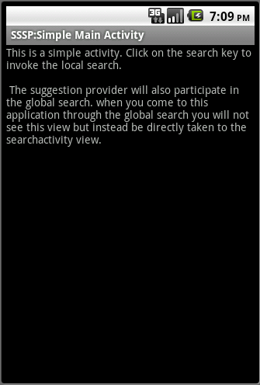
Figure 23–20. Simple suggestion provider: main activity (enabled for local search)
If you click the search key while this activity is in focus, you will see the local search invoked as in Figure 23–21.
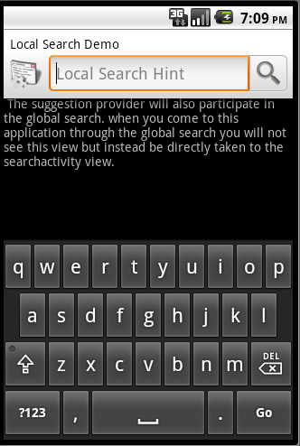

Figure 23–21. Simple suggestion provider: local search QSB
As you can see, there are no suggestions in Figure 23–21 because we haven’t searched for any so far. You can also see that this is a local search; the label and hint of the search are as we specified in the search metadata XML file.
Let us go ahead and search for string test1. This will take you to the Search Activity screen as shown in Figure 23–22.


Figure 23–22. Simple suggestion provider: local search results activity
As you can see from the SearchActivity source in Listing 23–17, SearchActivity does nothing spectacular on the screen, but behind the scenes it is saving the query strings in the database. Now if you navigate back to the main screen (by pressing the back button) and invoke search again you will see the following screen (as shown in Figure 23–23) where the search suggestions are populated with the previous query text. You can also see in Figure 23–23 the bottom part of the suggestion “SSSP”. This may seem extraneous here as this is a local search and clearly indicates that it comes from our application. However this string “SSSP” will distinguish the “test1” search string when it is displayed as part of the global search suggestions.
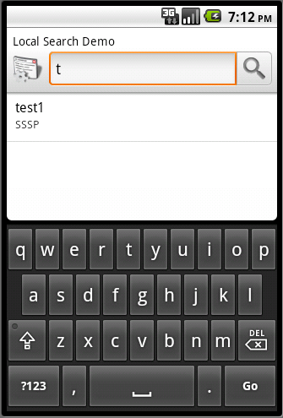
Figure 23–23. Simple suggestion provider: retrieved local suggestion
This is a good moment to see how we can invoke onNewIntent(). When you are on the search activity (Figure 23–22) you can type a letter like t and it will invoke the search again using type-to-search and you will see onNewIntent() called in the debug log.
Let us see what we need to see these suggestions show up in the global QSB. Because we have enabled includeInGlobalSearch in searchable.xml you should be able to see these suggestions in the global QSB as well. However, before you can do that you need to enable this application for global QSB suggestions as shown in Figure 23–24.
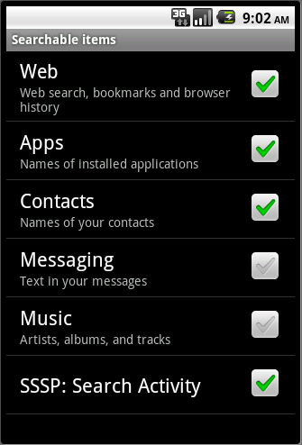
Figure 23–24. Enable simple suggestion provider
We showed you how to reach this screen at the beginning of the chapter. The simple custom suggestion provider we have coded is now available in the list of searchable applications as “SSSP:Search Activity”. This text string comes from the activity name for the SearchActivity (see Listing 23–16).
With this selection in place you can see the global search shown in Figure 23–25 working with our suggestion provider.
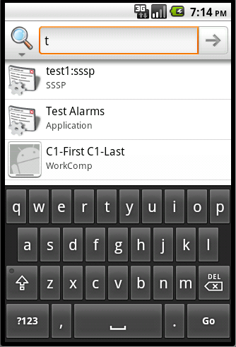
Figure 23–25. Global Suggestions From Simple Suggestion provider
In the global search, if you type a text like “t” it will bring up the suggestions from our suggestion provider of this section. When you navigate through the global search to the specific item you will see the local search activity as shown in Figure 23–22.
This concludes our discussion of the simple suggestion provider. You have learned about using the built-in RecentSearchSuggestionProvider to remember searches that are specific to your application. Using this approach, with minimal code you should be able to take local searches and make them available as suggestions even in a global context.
However, this simple exercise hasn’t shown you how to write suggestion providers from scratch. More important, we haven’t given you the slightest clue as to how a suggestion provider returns a set of suggestions and what columns are available in this suggestion set. To understand this and more, we need to implement a custom suggestions provider from scratch.

Implementing a Custom Suggestion Provider
Android search is too flexible not to customize. Because we used a pre-built suggestion provider in the last section, many features of a suggestion provider were hidden in the SearchRecentSuggestionsProvider and not discussed. We will explore these details next by implementing a custom suggestion provider called a SuggestUrlProvider.
We will start by explaining how this SuggestUrlProvider is expected work. We will then give you the file list in the implementation. These files should give you a general idea of how to build a custom suggestion provider.
Finally, we will show you how the completed application is used. Let’s get started.

Planning the Custom Suggestion Provider
We are going to call our custom suggestion provider a SuggestURLProvider. The object of this provider is to monitor what is being typed in the QSB. If the search query has text that looks something like “great.m” (the suffix .m is chosen to represent meaning) the provider will interpret the first part of the query as a word and suggest an Internet-based URL that can be invoked to look up the meaning of the word.
For every word, this provider suggests two URLs. The first is a URL that allows the user to search for the word using http://www.thefreedictionary.com and a second URL using http://www.google.com. Choosing one of these suggestions takes the user to one of these sites directly. If the user clicks on the search icon of the QSB, then the search activity will simply log the query text on a simple layout of this activity. You will see this more clearly when we show you the screen images of this interaction.
Let’s see the list of files that make up this project. You can also download the zip file for this project by following the URL at the end of this chapter.

SuggestURLProvider Project Implementation Files
The two primary files are SearchActivity.java and SuggestUrlProvider.java. However, you will need a number of supporting files to complete the project. Here is a list of these files and a brief description of what each one does. We have included the source code for all of the files with the solution.
- SuggestUrlProvider.java: This file implements the protocol of a custom suggestion provider. In this case the custom suggestion provider interprets query strings as words and returns a couple of suggestions using a suggestion cursor. (Listing 23–20)
- SearchActivity.java: This activity is responsible for receiving the queries or suggestions provided by the suggestion provider. SearchActivity definition is also responsible for tying up the suggestion provider with this activity. (Listing 23–23)
- layout/layout_search_activity.xml: This layout file is optionally used by the SearchActivity. In our example, we use this layout to log the query that is sent in. (Listing 23–24)
- values/strings.xml: Contains string definitions for the layout, local search title, local search hint, and the like. (Listing 23–25)
- xml/searchable.xml: Search metadata XML file that ties the SearchActivity, suggestion provider, and the QSB. (Listing 23–21)
- AndroidManifest.xml: application manifest file when the search activity and suggestion provider are defined. This is also where you declare that the SearchActivity is to be invoked as a local search for this application. (Listing 23–27)
We will start by exploring SuggestUrlProvider.

Implementing the SuggestUrlProvider Class
In our custom suggestion provider project, the SuggestUrlProvider class is the one that implements the protocol of the suggestion provider. We will explore the implementation of SuggestUrlProvider beginning with its responsibilities.

Responsibilities of a Suggestion Provider
At the core, a suggestion provider is a content provider. Much like a content provider a suggestion provider is invoked by Android search using a URI that identifies the provider and an additional argument representing the query.
Android search uses two types of URIs to invoke the provider. The first is called the search URI., This URI is used to collect the set of suggestions. The response needs to be one or more rows, with each row containing a set of well-known columns.
The second URI is called a suggest URI. This URI is used to update a suggestion that is previously cached. The response needs to be a single row containing a set of well-known columns.
A suggestion provider also needs to specify in the search metadata XML file (searchable.xml) how it wants to receive the search query, including as it is getting typed. This can be done through the select argument of the query method of a provider or the last path segment of the URI itself (which is also passed as one of the arguments to the query method of the provider).
For a suggestion provider there are a number of columns that are available, each enabling a certain search behavior. A provider first needs to decide on this set of controlling columns it wants to return. Some of these controlling columns are:
- A column to enable/disable caching of suggestions that are returned to the Android search.
- Columns to control if you want the suggestions to rewrite the text in the query box.
- Columns to invoke an action directly instead of showing a set of search results when the user clicks on a suggestion.

Overall Source Code for SuggestUrlProvider
Listing 23–20 is the source code for the SuggestUrlProvider class. Sections of this code are also examined in greater detail later in the chapter as we explain each of the listed responsibilities in greater detail.
Listing 23–20. CustomSuggestionProvider Source Code
public class SuggestUrlProvider extends ContentProvider
{
private static final String tag = "SuggestUrlProvider";
public static String AUTHORITY =
"com.androidbook.search.custom.suggesturlprovider";

private static final int SEARCH_SUGGEST = 0;
private static final int SHORTCUT_REFRESH = 1;
private static final UriMatcher sURIMatcher =
buildUriMatcher();

private static final String[] COLUMNS = {
"_id", // must include this column
SearchManager.SUGGEST_COLUMN_TEXT_1,
SearchManager.SUGGEST_COLUMN_TEXT_2,
SearchManager.SUGGEST_COLUMN_INTENT_DATA,
SearchManager.SUGGEST_COLUMN_INTENT_ACTION,

SearchManager.SUGGEST_COLUMN_SHORTCUT_ID
};

private static UriMatcher buildUriMatcher()
{
UriMatcher matcher =
new UriMatcher(UriMatcher.NO_MATCH);

matcher.addURI(AUTHORITY,
SearchManager.SUGGEST_URI_PATH_QUERY,
SEARCH_SUGGEST);
matcher.addURI(AUTHORITY,

SearchManager.SUGGEST_URI_PATH_QUERY +
"/*",

SEARCH_SUGGEST);
matcher.addURI(AUTHORITY,
SearchManager.SUGGEST_URI_PATH_SHORTCUT,

SHORTCUT_REFRESH);
matcher.addURI(AUTHORITY,

SearchManager.SUGGEST_URI_PATH_SHORTCUT +
"/*",

SHORTCUT_REFRESH);
return matcher;
}

@Override
public boolean onCreate() {
//lets not do anything in particular
Log.d(tag,"onCreate called");
return true;
}

@Override
public Cursor query(Uri uri, String[] projection,
String selection,
String[] selectionArgs, String sortOrder)
{
Log.d(tag,"query called with uri:" + uri);
Log.d(tag,"selection:" + selection);

String query = selectionArgs[0];
Log.d(tag,"query:" + query);

switch (sURIMatcher.match(uri)) {
case SEARCH_SUGGEST:
Log.d(tag,"search suggest called");
return getSuggestions(query);
case SHORTCUT_REFRESH:
Log.d(tag,"shortcut refresh called");
return null;
default:
throw
new IllegalArgumentException("Unknown URL " + uri);
}
}

private Cursor getSuggestions(String query)
{
if (query == null) return null;
String word = getWord(query);
if (word == null)
return null;

Log.d(tag,"query is longer than 3 letters");

MatrixCursor cursor = new MatrixCursor(COLUMNS);
cursor.addRow(createRow1(word));
cursor.addRow(createRow2(word));
return cursor;
}
private Object[] createRow1(String query)
{
return columnValuesOfQuery(query,
"android.intent.action.VIEW",
"http://www.thefreedictionary.com/" + query,
"Look up in freedictionary.com for",
query);
}

private Object[] createRow2(String query)
{
return columnValuesOfQuery(query,
"android.intent.action.VIEW",
"http://www.google.com/search?hl=en&source=hp&q=define%3A/"
+ query,
"Look up in google.com for",
query);
}
private Object[] columnValuesOfQuery(String query,
String intentAction,
String url,
String text1,
String text2)
{
return new String[] {
query, // _id
text1, // text1
text2, // text2
url,
// intent_data (included when clicking on item)
intentAction, //action
SearchManager.SUGGEST_NEVER_MAKE_SHORTCUT
};
}

private Cursor refreshShortcut(String shortcutId,
String[] projection) {
return null;
}

public String getType(Uri uri) {
switch (sURIMatcher.match(uri)) {
case SEARCH_SUGGEST:
return SearchManager.SUGGEST_MIME_TYPE;
case SHORTCUT_REFRESH:
return SearchManager.SHORTCUT_MIME_TYPE;
default:
throw
new IllegalArgumentException("Unknown URL " + uri);
}
}

public Uri insert(Uri uri, ContentValues values) {
throw new UnsupportedOperationException();
}

public int delete(Uri uri, String selection,
String[] selectionArgs) {
throw new UnsupportedOperationException();
}

public int update(Uri uri, ContentValues values,
String selection,
String[] selectionArgs) {
throw new UnsupportedOperationException();
}

private String getWord(String query)
{
int dotIndex = query.indexOf('.');
if (dotIndex < 0)
return null;
return query.substring(0,dotIndex);
}
}

Understanding Suggestion Provider URIs
Now that you have seen the complete source code of a custom suggestion provider, let’s look at how portions of this source code that fulfills the URI responsibilities.
First let’s look at the format of the URI that Android uses to invoke the suggestion provider. If our suggestion provider has an authority of
com.androidbook.search.custom.suggesturlprovider
then Android will send in two possible URIs. The first type of URI, a search URI, looks like one of the following:
content://com.androidbook.search.suggesturlprovider/search_suggest_query
or
content://com.androidbook.search.suggesturlprovider/search_suggest_query/<your-query>
This URI is issued when the user starts typing some text in the QSB. In one variation of this, the query is passed as an additional element at the end of the URI as a path segment. Whether or not to pass the query as a path segment is specified in the search metadata file searchable.xml. We will discuss that specification when we cover the search metadata in more detail.
The second type of URI that is targeted for a suggestion provider relates to Android search shortcuts. Android search shortcuts are suggestions (see Figure 23–3) that Android decides to cache, instead of calling the suggestion provider for fresh content. We will talk about Android search shortcuts more when we discuss the suggestion columns. For now, this second URI looks like the following:
content://com.androidbook.search.suggesturlprovider/search_suggest_shortcut
or this:
content://com.androidbook.search.suggesturlprovider/search_suggest_shortcut/<shortcut-id>
This URI is issued by Android when it tries to determine if the shortcuts that it had cached are still valid. This type of URI is called the shortcut URI. If the provider returns a single row it will replace the current shortcut with the new one. If the provider sends a null then Android assumes this suggestion is no longer valid.
The SearchManager class in Android defines two constants to represent these URI segments that distinguish them (search_suggest_search and search_suggest_shortcut). They are, respectively:
SearchManager.SUGGEST_URI_PATH_QUERY
SearchManager.SUGGEST_URI_PATH_SHORTCUT
It is the responsibility of the provider to recognize these incoming URIs in its query() method. See Listing 23–20 to see how the UriMatcher is used to accomplish this. (You can refer to Chapter 5 on how to use UriMatcher in greater detail.)

Implementing getType() and Specifying MIME Types
Because a suggestion provider is ultimately a content provider it has the responsibility of implementing a content provider contract, which includes defining an implementation for the getType() method.
You can consult Listing 23–20 again to see how getType() is implemented in this case. That code is replicated here for a quick review.
public String getType(Uri uri) {
switch (sURIMatcher.match(uri)) {
case SEARCH_SUGGEST:
return SearchManager.SUGGEST_MIME_TYPE;
case SHORTCUT_REFRESH:
return SearchManager.SHORTCUT_MIME_TYPE;
default:
throw
new IllegalArgumentException("Unknown URL " + uri);
}
}
Android search framework through its SearchManager class provides a couple of constants to help with these MIME types. These MIME types are

SearchManager.SUGGEST_MIME_TYPE

SearchManager.SHORTCUT_MIME_TYPE
These translate to
vnd.android.cursor.dir/vnd.android.search.suggest
vnd.android.cursor.item/vnd.android.search.suggest

Passing Query to the Suggestion Provider: The Selection Argument
When Android uses one of the URIs to call the provider, Android ends up calling the query() method of the suggestion provider to receive a suggestion cursor. If you see the implementation of the query() method in Listing 23–20 you will notice that we are using the selection argument and the selectionArgs argument in order to formulate and return the cursor. Here is that code replicated for quick review:
public Cursor query(Uri uri, String[] projection,
String selection,
String[] selectionArgs, String sortOrder)
{
Log.d(tag,"query called with uri:" + uri);
Log.d(tag,"selection:" + selection);

String query = selectionArgs[0];
Log.d(tag,"query:" + query);

switch (sURIMatcher.match(uri)) {
case SEARCH_SUGGEST:
Log.d(tag,"search suggest called");
return getSuggestions(query);
case SHORTCUT_REFRESH:
Log.d(tag,"shortcut refresh called");
return null;
default:
throw
new IllegalArgumentException("Unknown URL " + uri);
}
}
To understand what is passed to through the two arguments “selection” and “selectionArgs” you will need to see the searchable.xml, the search metadata file. Listing 23–21 shows the code for this search metadata XML file.
Listing 23–21. CustomSuggestionProvider Search Metadata
//xml/searchable.xml
<searchable
xmlns:android="http://schemas.android.com/apk/res/android"
android:label="@string/search_label"
android:hint="@string/search_hint"
android:searchMode="showSearchLabelAsBadge"
android:searchSettingsDescription="suggests urls"
android:includeInGlobalSearch="true"
android:queryAfterZeroResults="true"

android:searchSuggestAuthority=
"com.androidbook.search.custom.suggesturlprovider"

android:searchSuggestIntentAction=
"android.intent.action.VIEW"
android:searchSuggestSelection=" ? "
/>
Note: Please note the searchSuggestAuthority string value. It should match the corresponding content provider URL definition in the Android manifest file.
Notice the searchSuggestSelection attribute in the previous search metadata definition file listing. It directly corresponds to the selection argument of the content provider’s query() method. If you revisit Chapter4 you will know that this argument is used to pass the where clause with substitutable “?” symbols.
The array of substitutable values are then passed through the selectionArgs array argument. That indeed is the case here. When you specify searchSuggestSelection Android assumes that you don’t want to receive the search text through the URI but instead through the selection argument of the query() method. In that case Android search will send the "?" (notice the empty space before and after the “?” mark) as the value of the selection argument and passes the query text as the first element of the selection arguments array.
If you don’t specify the searchSuggestSelection, then it will pass the search text as the last path segment of the URI. You can choose one or the other. In our example, we have chosen the selection approach and not the URI approach.

Exploring Search Metadata for Custom Suggestion Providers
While we are on this topic of search metadata attributes, let’s explore what other attribute are available. We will cover those attributes that are often used or relevant to suggestion providers. For a complete list you can refer to the SearchManager API URL:
http://developer.android.com/guide/topics/search/searchable-config.html
The searchSuggestIntentAction attribute (Listing 23–21) is used to pass or specify the intent action when the SearchActivity is invoked through an intent. This allows the SearchActivity to do something other than the default search. Here is an example of how an intent action is used in the “onCreate()” of a responding search activity:
//Body of onCreate

// get and process search query here
final Intent queryIntent = getIntent();
//query action
final String queryAction = queryIntent.getAction();
if (Intent.ACTION_SEARCH.equals(queryAction))
{
this.doSearchQuery(queryIntent);
}
else if (Intent.ACTION_VIEW.equals(queryAction))
{
this.doView(queryIntent);
}
else {
Log.d(tag,"Create intent NOT from search");
}
You will see this code in context in the future Listing 23–23 where the searchActivity is looking for either a VIEW action or the SEARCH action by examining the action value of the intent.
Another attribute that we are not using here, but available to suggestion providers, is called searchSuggestPath. If specified, this string value is appended to the URI (one that invokes the suggestion provider) after the SUGGEST_URI_PATH_QUERY. This allows a single custom suggestion provider to respond to two different search activities. Each SearchActivity will use a different URI suffix. The suggestion provider can use this path suffix to return different set of results to a targeted search activity.
Just as with the Intent action, you can also specify intent data using the searchSuggestIntentData attribute. This is a data URI that can be passed along the action to the search activity, as part of the intent, when invoked.
The attribute called searchSuggestThreshold indicates the number of characters that have to be typed in QSB before invoking this suggestion provider. The default threshold value is zero.
The attribute queryAfterZeroResults (true or false) indicates if the provider should be contacted if the current set of characters returned zero set of results for the next set of characters. In our particular url suggest provider it is important to turn this flag on so that we get a look at the whole query text every time.
Now that we have looked at the URIs, selection arguments, and search metadata, let’s move on now to the most important aspect of a suggestion provider: the suggestion cursor.

Suggestion Cursor Columns
A suggestion cursor is, after all, a cursor. It is no different from the database cursors we discussed at length in Chapter 4. The suggestion cursor acts as the contract between the Android search facility and a suggestion provider. This means the names and types of the columns that the cursor returns are fixed and known to both parties.
To provide flexibility to search, Android search offers a large number of columns, most of which are optional. A suggestion provider does not need to return all these columns; it can ignore sending in the columns that are not relevant to this suggestion provider. In this section we will cover the meaning and significance of most of the columns (for the rest, you can refer to the SearchManager API URL, which we have mentioned a few times already).
First, we’ll talk about the columns that are available for a suggestion provider to return, what each column means, and how it affects search.
Like all cursors, a suggestion cursor also has to have an _id column. This is a mandatory column. Every other column starts with a SUGGEST_COLUMN_ prefix. These constants are defined as part of the SearchManager API reference. We will talk about the most frequently used columns below. For the complete list use the API references indicated at the end of this chapter.
- text_1: This is the first line of text in your suggestion (see Figure 23–3).
- text_2: This is the second line of text in your suggestion (see Figure 23–3).
- icon_1: This is the icon on the left side in a suggestion and is typically a resource ID.
- icon_2: This is the icon on the right side in a suggestion and is typically a resource ID.
- intent_action: This is what is passed to the SearchActivity when it is invoked as the intent action. This will override the corresponding intent action when available in the search metadata (see Listing 23–21).
- intent_data: This is what is passed to the SearchActivity when it is invoked as the intent data. This will override the corresponding intent action when available in the search metadata (see Listing 23–21). This is a data URI.
- intent_data_id: This gets appended to the data URI. It is especially useful if you want to mention the root part of the data in the metadata one time and then change this for each suggestion. It is a bit more efficient that way.
- query: The query string to be used to send to the search activity.
- shortcut_id: As indicated earlier, Android search caches suggestions provided by a suggestion provider. These cached suggestions are called shortcuts. If this column is not present, Android will cache the suggestion and will never ask for an update. If this contains a value equivalent to SUGGEST_NEVER_MAKE_SHORTCUT, then Android will not cache this suggestion. If it contains any other value, this ID is passed as the last path segment of the shortcut URI. (See the section “Understanding Suggestion Provider URIs.”)
- spinner_while_refreshing: This boolean value will tell Android if it should use a spinner when it is in the process of updating the shortcuts.
There is a variable set of additional columns for responding to action keys. We will cover that in the action keys section later. Let’s see how our custom suggestion provider returns these columns.

Populating and Returning the List of Columns
Each custom suggestion provider is not required to return all these columns. For our suggestion provider we will return only a subset of the columns based on the functionality indicated in the “Planning the Custom Suggestion Provider” section.
By looking at Listing 23–20 you can see that out list of columns is as follows (extracted and reproduced in Listing 23–22).
Listing 23–22. Defining Suggestion Cursor Columns
private static final String[] COLUMNS = {
"_id", // must include this column
SearchManager.SUGGEST_COLUMN_TEXT_1,
SearchManager.SUGGEST_COLUMN_TEXT_2,
SearchManager.SUGGEST_COLUMN_INTENT_DATA,
SearchManager.SUGGEST_COLUMN_INTENT_ACTION,
SearchManager.SUGGEST_COLUMN_SHORTCUT_ID
};
These columns are chosen so that the following functionality is met:
The user enters a word with a hint like “great.m” in the QSB, our suggestion provider will not respond until there is a “.” in the search text. Once it is recognized, the suggestion provider will extract the word from it (in this case, “great”) and then provide two suggestions back.
The first suggestion is to invoke the thefreewebdictionary.com with this word and a second suggestion is to search Google with a pattern of define:great.
To accomplish this, the provider loads up the column intent_action as intent.action.view and the intent data containing the entire URI. The hope is that Android will launch the browser when it sees the data URI starting with http://.
We will populate the text1 column with search some-website with: and text2 with the word itself (again, great, in this case). We will also set the shortcut ID to SUGGEST_NEVER_MAKE_SHORTCUT to simplify things. This setting disables caching and also prevents the suggest shortcut URI being fired.
This completes our analysis of custom suggestion provider class source code. We have learned about URIs, suggestion cursors, and suggestion provider–specific search metadata. We also know how to populate suggestion columns.
Now let’s look into implementing the search activity for our custom suggestion provider.

Implementing a Search Activity for a Custom Suggestion Provider
During the simple suggestion provider implementation we covered only some of the responsibilities of a search activity. Now let’s look at the aspects we overlooked.
Android search invokes a search activity in order to respond to search actions from one of two ways. This can happen either when a search icon is clicked from the QSB or when the user directly clicks on a suggestion.
When invoked, a search activity needs to examine why it is invoked. This information is available in the intent action. The search activity needs to examine intent action to do the right thing. In many cases, this action is ACTION_SEARCH. However, a suggestion provider has the option of overriding it by specifying an explicit action either through search metadata or through a suggestion cursor column. This type of action can be anything. In our case, we are going to be using a VIEW action.
As we pointed out in our discussion of the simple suggestion provider, it is also possible to set up the launch mode of the search activity as a singleTop. In this case, the search activity has the added responsibility of responding to onNewIntent() in addition to onCreate(). We will cover both these cases and show how similar they are.
We will use both onNewIntent() and onCreate() to examine both ACTION_SEARCH and also ACTION_VIEW. In case of search action we will simply display the query text back to the user. In case of view action we will transfer control to a browser and finish the current activity so that the user has the impression of invoking the browser by directly clicking on the suggestion.
Note: This SearchActivity does not need to be a launchable activity from the main applications menu of Android. Make sure you don’t inadvertently set intent filters for this activity like other activities that need to be invoked from the device main applications screen.
With that, let’s examine the source code of SearchActivity.java.

SearchActivity for a Custom Suggestion Provider
Now that we know the responsibilities of a search activity and, specifically, which ones are applicable for our example, we can show you the source code of this search activity (Listing 23–23).
Listing 23–23. SearchActivity
//file: SearchActivity.java
public class SearchActivity extends Activity
{
private final static String tag ="SearchActivity";
@Override
protected void onCreate(Bundle savedInstanceState) {
super.onCreate(savedInstanceState);

Log.d(tag,"I am being created");
setContentView(R.layout.layout_test_search_activity);

// get and process search query here
final Intent queryIntent = getIntent();

//query action
final String queryAction = queryIntent.getAction();
Log.d(tag,"Create Intent action:"+queryAction);

final String queryString =
queryIntent.getStringExtra(SearchManager.QUERY);
Log.d(tag,"Create Intent query:"+queryString);

if (Intent.ACTION_SEARCH.equals(queryAction))
{
this.doSearchQuery(queryIntent);
}
else if (Intent.ACTION_VIEW.equals(queryAction))
{
this.doView(queryIntent);
}
else {
Log.d(tag,"Create intent NOT from search");
}
return;
}

@Override
public void onNewIntent(final Intent newIntent)
{
super.onNewIntent(newIntent);
Log.d(tag,"new intent calling me");

// get and process search query here
final Intent queryIntent = newIntent;

//query action
final String queryAction = queryIntent.getAction();
Log.d(tag,"New Intent action:"+queryAction);

final String queryString =
queryIntent.getStringExtra(SearchManager.QUERY);
Log.d(tag,"New Intent query:"+queryString);

if (Intent.ACTION_SEARCH.equals(queryAction))
{
this.doSearchQuery(queryIntent);
}
else if (Intent.ACTION_VIEW.equals(queryAction))
{
this.doView(queryIntent);
}
else {
Log.d(tag,"New intent NOT from search");
}
return;
}
private void doSearchQuery(final Intent queryIntent)
{
final String queryString =
queryIntent.getStringExtra(SearchManager.QUERY);
appendText("You are searching for:" + queryString);
}
private void appendText(String msg)
{
TextView tv = (TextView)this.findViewById(R.id.text1);
tv.setText(tv.getText() + "\n" + msg);
}
private void doView(final Intent queryIntent)
{
Uri uri = queryIntent.getData();
String action = queryIntent.getAction();
Intent i = new Intent(action);
i.setData(uri);
startActivity(i);
this.finish();
}
}
We’ll start our analysis of this source code by examining first how this search activity is invoked.

Details of SearchActivity Invocation
Like all activities, we know that a search activity must have been invoked through an intent. However, it would be wrong to assume that it is always the action of the intent that is responsible for this. As it turns out, the search activity is invoked explicitly through its component name specification.
You might ask why this is important. Well, we know that in our suggestion provider we are explicitly specifying an intent action in the suggestion row. If this intent action is VIEW and the intent data is an HTTP URL, then an unsuspecting programmer would think that a browser will be launched in response, and not the search activity. That would certainly be desirable. But because the ultimate intent is also loaded with the component name of search activity in addition to the intent action and data, the component name will take precedence.
We are not sure why this restriction is there or how to overcome it. But the fact is, irrespective of the intent action that your suggestion provider specifies, search activity is the one that is going to be invoked. In our case, we will simply launch the browser from the search activity and close the search activity.
To demonstrate this, here is the intent that Android fires off to invoke our search activity when we click on a suggestion:
launching Intent {
act=android.intent.action.VIEW
dat=http://www.google.com
flg=0x10000000
cmp=com.androidbook.search.custom/.SearchActivity (has extras)
}
Notice the component spec of the intent. It is directly pointing to the search activity. So no matter what intent action you indicate, Android will always invoke search activity. As a result, it becomes the responsibility of the search activity to invoke the browser.
Now let’s look at what we do with these intents in the search activity.

Responding to ACTION_SEARCH and ACTION_VIEW
We know that a search activity is explicitly invoked by name by Android search. However, the invoking intent also carries with it the action that is specified. When QSB invokes this activity through the search icon this action is ACTION_SEARCH.
This action could be different if it was invoked by a search suggestion. It depends on how the suggestion provider set up the suggestion. In our case, the suggestion provider set this up as an ACTION_VIEW.
As a result, a search activity needs to examine the type of action. Here is how we examine this code to see whether to call a search query method or the view method. (This code segment is extracted from Listing 23–23):
if (Intent.ACTION_SEARCH.equals(queryAction))
{
this.doSearchQuery(queryIntent);
}
else if (Intent.ACTION_VIEW.equals(queryAction))
{
this.doView(queryIntent);
}
From the code you can see that we invoke doView() for a view action and doSearchQuery() in the case of a search action.
In the doView() function we will retrieve the action and the data URI and populate a new intent with them and then invoke the activity. This will invoke the browser. We will finish the activity so that the back button takes you back to whatever search invoked it.
In the doSearchQuery() we are just logging the search query text to the view. Let us take a look at the layout that is used to support doSearchQuery().

Search Activity Layout
Listing 23–24 is a simple layout that is used by a search activity in case of doSearchQuery().The only important element is highlighted in bold.
Listing 23–24. SearchActivity Layout XML
<?xml version="1.0" encoding="utf-8"?>
<!-- file: layout/layout_search_activity.xml -->
<LinearLayout xmlns:android="http://schemas.android.com/apk/res/android"
android:orientation="vertical"
android:layout_width="fill_parent"
android:layout_height="fill_parent"
>
<TextView
android:id="@+id/text1"
android:layout_width="fill_parent"
android:layout_height="wrap_content"
android:text="@string/search_activity_main_text"
/>
</LinearLayout>

It is appropriate at this point to show you the strings.xml that is responsible for some of the text needs of this application.

Corresponding strings.xml
This strings.xml as shown in Listing 23–25 defines text strings for the layout and also such things as the name of the application, some strings for configuring the local search, and the like.
Listing 23–25. strings.xml
<?xml version="1.0" encoding="utf-8"?>
<!-- file: values/strings.xml -->
<resources>
<string name="search_activity_main_text">
This is the search activity.
\n\n
This will be invoked if action_search
is used as opposed to action_view.
\n\n
action_search happens if you press the search icon.
\n\n
action_view happens if you press on the suggestion
</string>

<string name="app_name">Custom Suggest Application
</string>

<string name="search_label">Custom Suggest Demo
</string>

<string name="search_hint">Custom Suggest Demo Hint
</string>
</resources>

Responding to onCreate() and onNewIntent()
If you examine Listing 23–23, you will see that the code in onCreate() and onNewIntent() is almost identical. This is not an uncommon pattern.
When a search activity is invoked, depending on the launch mode of the search activity, either onCreate() or a onNewIntent() is called.
Note: For a useful reference on launch modes and onNewIntent() see the “References” section at the end of this chapter.

Notes on Finishing a Search Activity
Earlier in this discussion we briefly mentioned how to respond to doView(). Listing 23–26 is the code for this function (excerpted from Listing 23–26).
Listing 23–26. Finishing the Search Activity
private void doView(final Intent queryIntent)
{
Uri uri = queryIntent.getData();
String action = queryIntent.getAction();
Intent i = new Intent(action);
i.setData(uri);
startActivity(i);
this.finish();
}
The goal of this function is to invoke the browser. If we were not doing the finish() at the end, the user would be taken back to the search activity from the browser after clicking the back button, instead of back to the search screen where they came from, as expected.
Ideally, to give the best user experience the control should never pass through the search activity. Finishing this activity solves that problem. Listing 23–26 also gives us an opportunity to examine how we transfer the intent action and intent data from the original intent (which are set by the suggestion provider) and then pass them on to a new browser intent.
We just covered a lot of ground. We have shown you a detailed suggestion provider implementation and a search activity implementation. In the process, we have also shown you the search metadata file and the strings.xml. We will conclude our examination of the files needed for implementing this chapter’s project with a look at the application level manifest file.

Custom Suggestions Provider Manifest File
The manifest file is where you bring together many components of your application. For our custom suggestions provider application as in other examples, this is where you declare its components, such as the search activity and the suggestion provider. You also use the manifest file to declare that this application is enabled for local search by declaring the “search activity” as the default search. Also pay attention the intent filters defined for the search activity.
These details are highlighted bold in the manifest file code (Listing 23–27).
Listing 23–27. Custom Suggestion Provider Manifest File
//file:AndroidManifest.xml
<?xml version="1.0" encoding="utf-8"?>
<manifest xmlns:android="http://schemas.android.com/apk/res/android"
package="com.androidbook.search.custom"
android:versionCode="1"
android:versionName="1.0.0">
<application android:icon="@drawable/icon"
android:label="Custom Suggestions Provider">
<!--
****************************************************************
* Search related code: search activity
****************************************************************
-->
<activity android:name=".SearchActivity"
android:label="Search Activity Label"
android:launchMode="singleTop">
<intent-filter>
<action
android:name="android.intent.action.SEARCH" />
<category
android:name="android.intent.category.DEFAULT" />
</intent-filter>

<meta-data android:name="android.app.searchable"
android:resource="@xml/searchable" />
</activity>

<!-- Declare default search -->
<meta-data android:name="android.app.default_searchable"
android:value=".SearchActivity" />

<!-- Declare Suggestion Provider -->
<provider android:name="SuggestUrlProvider"
android:authorities=
"com.androidbook.search.custom.suggesturlprovider" />
</application>
<uses-sdk android:minSdkVersion="4" />
</manifest>
As you can see, we have highlighted three things:
- Defining the search activity along with its search metadata XML file
- Defining the search activity as the default search for the application
- Defining the suggestion provider and its authority
With all of the source code in place, it is time to take a tour of the application and see how it looks in the emulator.

Custom Suggestion User Experience
Once you build and deploy this app through ADT you will not see any activity pop-up because there is no activity to start. Instead, you will see that the application is successfully installed in the Eclipse console.
This means that the suggestion provider is ready to respond to the global QSB. But before that can take place, you will need to enable this suggestion provider to participate in global search.
Earlier in this chapter we showed you how to reach the search settings application. Here is a shortcut which uses the very search facility we have learned so far.
Open the global QSB and type sett in the QSB. This will bring up the settings application as one of the suggestions to be invoked. See Figure 23–26.
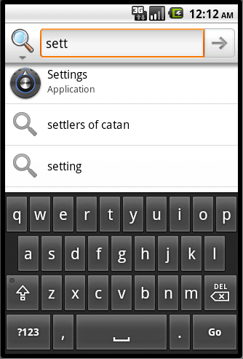
Figure 23–26. Invoking settings through search
Notice how we are using what we have learned about QSB to invoke the settings application. Follow the approach specified at the beginning of this chapter to enable this application for suggestions. Once this is done, type the text in the QSB shown in
Figure 23–27.

Figure 23–27. More results from the custom suggestions provider
Notice how search suggestions from the custom suggestions provider are presented. Now if you click on the search icon on the top left and change the search application to the “custom suggestion provider” application and navigate to one of the suggestions provided by our custom suggestions provider and click the QSB search icon, Android will take you to the search activity directly without invoking any browser, as shown in Figure 23–28. (This demonstrates the two types of intent actions we discussed: the search and the view.)
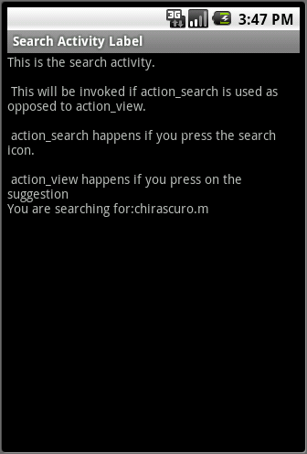
Figure 23–28. Query search invoking search results
So this example demonstrates the ACTION_SEARCH vs. the ACTION_VIEW.
Now if you click on the free dictionary suggestion in Figure 23–27, you will see the invoked browser as in Figure 23–29.
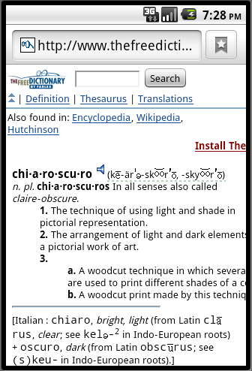
Figure 23–29. Free dictionary
If you click on the Google suggestion item in Figure 23–27, you will see the browser shown in Figure 23–30.
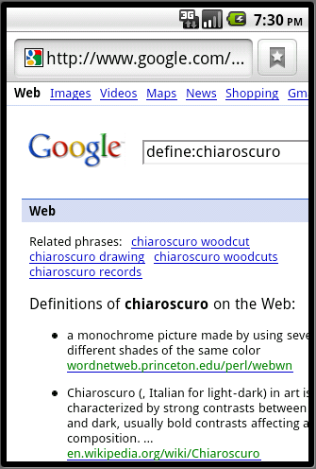
Figure 23–30. Searching Google for a definition
Figure 23–31 shows what happens if you don’t type the suffix .m in the global search.
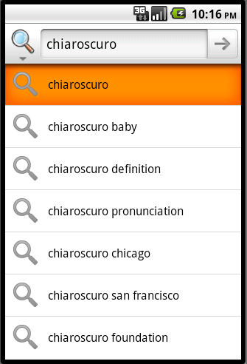
Figure 23–31. Custom provider without a hint
Notice how the suggestion provider hasn’t provided anything back.
This concludes our discussion of building a functional custom suggestions provider from scratch. Although we’ve covered any aspects of search, there are still a couple of topics that we haven’t talked about. These are action keys and Application-Specific search data. We will cover these next.

Using Action Keys and Application-Specific Search Data
Action keys and application-specific search data add further flexibility to Android search.
Action keys allow us to employ specialized device keys for search-related functionality. Application-specific search data allow an activity to pass additional data to the search activity.
Note: Please note that the code listings in the rest of the chapter do not form a testable project. These code listings are there only to support the ideas presented in text.
Let’s begin with action keys.

Using Action Keys in Android Search
So far we’ve shown a number of ways to invoke search:
- The search icon available in the QSB
- The search key that is part of a set of action keys (shown on the right side of Figure 23–1)
- An explicit icon or button that is displayed by an activity
- Any key press based on a type-to-search declaration
In this section we will look at invoking search through action keys. Action keys are a set of keys available on the device which are tied to specific actions. Some examples of these action keys are shown in Listing 23–28.
Listing 23–28. List of Action Key Codes
keycode_dpad_up
keycode_dpad_down
keycode_dpad_left
keycode_dpad_right
keycode_dpad_center
keycode_back
keycode_call
keycode_camera
keycode_clear
kecode_endcall
keycode_home
keycode_menu
keycode_mute
keycode_power
keycode_search
keycode_volume_up
keycode_volume_down
You can see these action keys defined in the API for KeyEvent, which is available at http://developer.android.com/reference/android/view/KeyEvent.html
Note: Not all of these action keys can be co-opted for search, but some can, such as keycode_call. You will have to try each and see which is suitable for your need.
Once you know which action key you want to use you can tell Android that you are interested in this key by dropping it in the metadata using the XML segment in Listing 23–29.
Listing 23–29. Action Key Definition Example
<searchable xmlns:android="http://schemas.android.com/apk/res/android"
android:label="@string/search_label"
android:hint="@string/search_hint"
android:searchMode="showSearchLabelAsBadge"

android:includeInGlobalSearch="true"
android:searchSuggestAuthority=
"com.androidbook.search.simplesp.SimpleSuggestionProvider"
android:searchSuggestSelection=" ? "
>
<actionkey
android:keycode="KEYCODE_CALL"
android:queryActionMsg="call"
android:suggestActionMsg="call"
android:suggestActionMsgColumn="call_column" />

<actionkey
android:keycode="KEYCODE_DPAD_CENTER"
android:queryActionMsg="doquery"
android:suggestActionMsg="dosuggest"
android:suggestActionMsgColumn="my_column" />
.....
</searchable>
You can also have multiple action keys for the same search context. Here is what each attribute of the actionKey element stands for and how it is used to respond to an action key press.
- keycode: This is the key code as defined in the KeyEvent API class that should be used to invoke the search activity. There are two times when this key identified by the keycode can be pressed. The first is when the user enters query text in the QSB but hasn’t navigated to any suggestions. Typically the user, without an action key implementation, will have pressed the search icon of the QSB. With an action key specified in the metadata of the search, Android allows the user to click the action key instead of the QSB search Go icon. The second is when the user navigates to a specific suggestion and then clicks the action key. In both cases the search activity is invoked with an action of ACTION_SEARCH. To know that this action is invoked through an action key, look for an extra string called SearchManager.ACTION_KEY. If you see a value here, you know that you are being called in response to an action key press.
- queryActionMsg: Any text you enter in this element is passed to the search activity invoking intent as an extra string called SearchManager.ACTION_MSG. If you retrieve this message from the intent and it is the same as what you have specified in the metadata, then you know that you are being called directly from the QSB as a result of clicking on the action key. Without this test, you will not know if the ACTION_SEARCH is called due to an action key click on the suggestion directly.
- suggestActionMsg: Any text you enter in this element is passed to the search activity invoking intent as an extra string called SearchManager.ACTION_MSG. The extra keys for this and the queryActionMsg are the same. If you give the same value for both of these fields, such as call, then you will not know in what way user has invoked the action key. In many cases, this is irrelevant so you can just give the same value for both. But if you have a need to distinguish one from the other, you will need to specify a value that is different from the queryActionMsg.
- suggestActionMsgColumn: The values queryActionMsg and suggestActionMsg apply globally to this search activity and the suggestion provider. There isn’t a way to alter the action meaning based on the suggestion. If you would like to do that then you will need to tell the metadata that there is an extra column in the suggestion cursor. This will allow Android to pick up the text from that extra column and send it to the activity as part of the invoking ACTION_SEARCH intent. Interestingly, the value of this additional column is sent through the same extra key in the intent, namely SearchManager.ACTION_MSG.
Among these attributes the key code is mandatory. In addition, there needs to be at least one of the additional three attributes present for the action key to fire.
If you were to use the suggestActionMsgColumn, you would need to populate this column in the suggestion provider class. In Listing 23–29 if you were to use both these keys then you would need to have two additional string columns defined in the suggest cursor (see Listing 23–22), namely call_column and my_column. In that case, your cursor column array would be as shown in Listing 23–30.
Listing 23–30. Example of Action Key Columns in the Suggestion Cursor
private static final String[] COLUMNS = {
"_id", // must include this column
SearchManager.SUGGEST_COLUMN_TEXT_1,
SearchManager.SUGGEST_COLUMN_TEXT_2,
SearchManager.SUGGEST_COLUMN_INTENT_DATA,
SearchManager.SUGGEST_COLUMN_INTENT_ACTION,
SearchManager.SUGGEST_COLUMN_SHORTCUT_ID,
"call_column",
"my_column"
};

Working with Application-Specific Search Context
Android search allows an activity to pass additional search data to the search activity when it is invoked. We will walk through the details of this now.
As we have shown, an activity in your application can override the onSearchRequested() method to disable search by returning false. Interestingly, the same method can be used instead to pass additional application-specific data to the search activity. Listing 23–31 is an example.
Listing 23–31. Passing Additional Context
public boolean onSearchRequested()
{
Bundle applicationData = new Bundle();
applicationData.putString("string_key","some string value");
applicationData.putLong("long_key",290904);
applicationData.putFloat("float_key",2.0f);

startSearch(null, // Initial Search search query string
false, // don't "select initial query"
applicationData, // extra data
false // don't force a global search
);

return true;
}
Note: You can use the following Bundle API reference to see the various functions available on the bundle object: http://developer.android.com/reference/android/os/Bundle.html.
Once the search has started this way, the activity can use the extra called SearchManager.APP_DATA to retrieve the application data bundle. Listing 23–32 shows how you can retrieve each of the above fields.
Listing 23–32. Retrieving Additional Context

Bundle applicationData =
queryIntent.getBundleExtra(SearchManager.APP_DATA);
if (applicationData != null)
{
String s = applicationData.getString("string_key");
long l = applicationData.getLong("long_key");
float f = applicationData.getFloat("float_key");
}
We have introduced the startSearch() method earlier in the chapter briefly. You can find more about this method at the following URL as part of the Activity API:
http://developer.android.com/reference/android/app/Activity.html
Once again this method takes the following four arguments
- initialQuery // a string argument
- selectInitialQuery // boolean
- applicationDataBundle //Bundle
- globalSearchOnly //boolean
The first argument, if available, will populate the query text in the QSB.
The second boolean argument will highlight the text if true. Doing so will enable the user to replace all of the selected query text with what is typed over. If this is false, then the cursor will be at the end of the query text.
The third argument is, of course, the bundle that we are preparing.
The fourth argument, if true, will always invoke a global search. If it is false, then the local search is invoked first, if available; otherwise, it will use the global search.

Resources
As we come to the end of this chapter, we would like to give you a list of resources that we found valuable in writing it.
- www.google.com/googlephone/AndroidUsersGuide.pdf: This is a good Android 2.2.1 reference for understanding how to use Android Search from a user’s perspective.
- www.google.com/help/hc/pdfs/mobile/AndroidUsersGuide-30-100.pdf: This is a users guide for Android 3.0 release. These URLs seem to change quickly every couple of months. You should be able to locate by searching google using the key words "Android User's Guide"
- http://developer.android.com/reference/android/app/SearchManager.html: You can use this URL to find the main documentation on Android search from Google. The same URL also works as the API reference for the main Android search facility, namely SearchManager
- http://developer.android.com/reference/android/app/Activity.html#onNewIntent(android.content.Intent): As you design your own search activities, it is sometimes advantageous to set them up as singleTop resulting in the generation of a onNewIntent(). You can find more about this method here.
- http://developer.android.com/guide/samples/SearchableDictionary/index.html: You can refer to this Google sample online to see how an example suggestion provider is implemented. This link points to the source code of the implementation.
- http://developer.android.com/reference/android/provider/SearchRecentSuggestions.html: At this URL you can read about the Search Recent Suggestions API.
- http://developer.android.com/guide/topics/fundamentals.html: This site will help you understand activities, tasks, and launch modes, especially the singleTop launch mode, which is used often as a search activity.
- http://developer.android.com/reference/android/os/Bundle.html:YYou can use this Bundle API reference to see the various functions available on the bundle object. This is useful for application-specific search data.
- http://www.androidbook.com/notes_on_search: At this URL you can find the authors’ notes on Android search. We will continue to update the content even after this book goes to press.
- http://www.androidbook.com/projects: You can use this URL to download the test projects dedicated for this chapter. The name of the zip files for this chapter are: ProAndroid3_ch23_SearchRegularActivities.zip, ProAndroid3_ch23_SimpleSuggestionProvider.zip, ProAndroid3_ch23_CustomSuggestionProvider.zip.

Implications for Tablets
The underlying Search API remains unchanged in 3.0. However the QSB and search settings (essentially the user experience) are altered slightly to make use of more real estate. Other than that the ideas presented in this chapter are equally applicable for tablets.

Summary
In this chapter we presented, in a fair amount of detail, the internal workings of Android search. You have learned how activities and suggestion providers interact with Android search. We have showed you how to use the SearchRecentSuggestionsProvider.
We coded from scratch a custom suggestions provider and, in the process, demonstrated the suggestion cursor and its columns in detail. We explored the URIs that are responsible for getting data from suggestion providers. We have presented a lot of sample code that should make it easy to devise and implement your creative search strategies.
Based on the flexibility of the suggestion cursor alone, Android search transcends a simple search to a conduit of information at fingertips.

