Chapter
17
Titanium Mobile: A WebKit-Based Approach to Android Development
In this chapter, we are going to introduce a novel yet complementary approach to programming applications on the Android platform, inspired by the trend that began with RIA (Rich Internet Applications). Some of the key features of RIA are the ability to drag and drop, provide animation, and talk to servers without refreshing through HTML browsers. Although these activities have been traditionally accomplished through plug-ins such as Flash, recent advances in RIA accomplish them by taking advantage of the HTML DOM (Document Object Model).
Titanium Mobile is a product from Appcelerator Inc. (http://www.appcelerator.com) that brings the advances of RIA to mobile devices. In addition to bringing this new RIA model to the popular mobile platforms (Android and iPhone), Titanium Mobile is also open source and licensed under the Apache v2.0 license. In this chapter, we will introduce you to this new, yet familiar, paradigm and walk you through the architecture and mechanics of Titanium Mobile.
We’ve organized this chapter into three sections. We will start with an overview of Titanium Mobile and cover its history, architecture, and programming ecosystem. We’ll show you how to sign up for and download Titanium Mobile. We’ll introduce you to the components of the Titanium Developer, including its sandbox, where you will type and test a few lines of stand-alone javascript code which will say “Hello World”.
In the second section, we will walk you through the lifecycle of a project using a simple “Hello World” project. Unlike the sandbox example, this project has a formal structure which you can build and distribute. In this second section we will create the project, test it on an emulator, package the project as an .apk file, and sign the .apk file so that it can be installed on other emulator instances and devices.
In the third section, we will cover what it takes to write client-side applications in JavaScript without help from a server-side UI framework such as JSP (Java Server Pages) or ASP.NET. This topic will cover advanced JavaScript that you will need. We will also cover a critical JavaScript library called JQuery. We will also briefly enumerate a number of JavaScript API wrappers to the native Android platform provided by Titanium Mobile. We will conclude the chapter by drawing out the significance of this approach to Android development.
Note: A Titanium-like approach to Android application development can supplement your development efforts by giving you a faster and prettier path to application development. The “prettier” path comes from the simplicity and flexibility of the HTML and CSS UI. This is not to mention the platform-independent abstraction provided by Titanium Mobile, which can also make your application run on multiple mobile platforms.
Before we start, we want to point out that this chapter offers an introduction to Titanium Mobile; we will not attempt to cover Titanium Mobile in depth. However, we will provide a clear roadmap to the maze of open source tools you will need to make this paradigm work. This is important, as the documentation on the Titanium Mobile web site assumes that the developer is already familiar with the Web 2.0 development paradigm.

Titanium Mobile Overview
If you are a web developer, you may already be familiar with some of the technologies and tools in the browser and RIA space such as Flash/Flex from Adobe, SilverLight from Microsoft, JavaFx from Sun, and Laszlo from Laszlo Systems.
These RIA tools provide rich interaction to the user by allowing such things as drag and drop, animation, tree controls, and richer tables.
Flash/Flex does this through the Flash browser plug-in. Silverlight does this through a Dotnet browser plug-in that provides the CLR (Common Language Runtime) environment. JavaFx does this through JRE (Java Runtime Engine). Laszlo does this by co-opting the Flash plug-in as well.
There is one technology in RIA space that doesn’t use any plug-ins but uses native browser controls. In this alternative, JavaScript libraries, taking advantage of HTML DOM (Document Object Model), have allowed programming in RIA directly without any plug-ins. These JavaScript libraries provide a surprisingly capable architecture for building RIA through DOM and Ajax (Asynchronous JavaScript and XML).
Note: If you are not familiar with DOM or Ajax, please refer to external sources to understand how they contribute to RIA.
This JavaScript/HTML-based RIA approach, which doesn’t use any new plug-ins, allows for a development gradient where you can become sophisticated over time without having to commit to a steep learning curve up front.
This is all fine for web development, you may say, but what has this got to do with developing on Android when we are talking about native applications? As it turns out, the browser in Android is Chrome based, which in turn is based on the seemingly ubiquitous WebKit engine that powers web browsers such as Chrome and Safari.
Technologies are emerging that allow you to drive the WebKit natively using HTML and JavaScript files stored on the local device. This is where Titanium Mobile comes into play. Titanium Mobile exploits the WebKit to provide cross-platform solutions that locally run on Windows desktops, Mac desktops, iPhone, and the Android OS.
Note: Appcelerator Inc. (originally called Hakano) is based in Mountain View, California, and was founded in 2006 by Jeff Haynie and Nolan Wright with product offerings developed around Web 2.0. In early 2008, they extended their product strategy to use a WebKit-based, cross-platform approach for desktops and mobile platforms. These efforts have resulted in the Titanium product suite.
Let’s look now at the kind of architecture Titanium Mobile has under the hood to provide a rich user experience and also cross-platform compatibility.

Architecture
At the core, Titanium Mobile is a wrapper for working with WebKit, which is available on Android and other mobile devices such as iPhone. Titanium Mobile then supplements the WebKit capabilities by providing a set of JavaScript APIs that map to the native Android libraries such as file systems and media. This JavaScript-based API abstraction on a native device gives a uniform API to a seasoned web developer to write applications to the native OS interface. How Titanium accomplishes this at a high level is depicted in Figure 17–1.
The figure has three main sections or blocks: B1, B2, and B3. B1 is the project that you maintain for developing one of your applications. B2 is the Titanium Developer IDE. (We sometimes call this simply the Titanium IDE.) B3 represents the Android emulator or the device.
A Titanium project represented by B1 is just a directory on your hard drive where you keep your HTML resources. Other than some housekeeping files and build files, most of your source files are kept in a subdirectory called Resources. This project directory is known to the Titanium IDE (in Figure 17–1 this relationship is identified as line L1).
The JavaScript in this project has access to native JavaScript libraries provided by the Titanium Developer IDE. This native JavaScript comes with the Titanium IDE and is indicated inside the Titanium IDE box (B2). This relationship is indicated through line L2.
Titainium IDE will take the project and create an .apk file, which is then installed on the device (B3). This is indicated by Generate (L3) and Build (L4) lines.
Note: The IDE actually creates an intermediate project (line L3) resembling an Eclipse ADT project before building it. This is important to know because it is possible to take this intermediate project and actually debug it in the Eclipse IDE.
Once installed, this .apk file will drive the WebKit (line L6) through the available resource files. When the .apk is installed on the device, the files from Resources subdirectory (HTML, image, JavaScript, CSS, etc.) will be copied to the device as well. This is how WebKit is able to locate relative HTML files (line L7).
The JavaScript code from the HTML files (which themselves are part of the .apk) will also have access to the native Android platform through Native JavaScript APIs provided by the Titanium Developer (line L5).
Figure 17–1. Titanium Mobile high-level architecture
Now that we have briefly explored the Titanium Mobile architecture diagram for Android, we’ll explore each of the following architectural components in a bit more detail:
- A Titanium project containing resources
- The Titanium IDE
- How to build and deploy the project on a device

Nature of a Titanium Project
A Titanium Mobile project is very much like an HTML development project where you have an index.html and a series of subdirectories where you keep HTML files, CSS files, and other JavaScript libraries (both yours and third party’s). Titanium calls this root directory a Resources directory and is represented in the diagram as a Resources box inside the B1 box.
This Resources subdirectory is created for you when you use the Titanium IDE and create a project. You will see in the examples that follow later in this chapter the exact directory structure for this project. Developers can choose to use any set of JavaScript libraries that they are familiar with. There is also a set of JavaScript APIs that Titanium makes available to your JavaScript code.

Components of the Titanium Developer IDE
Let’s talk about the components of the Titanium Developer IDE (represented by box B1 in Figure 17–1). Strictly speaking, this is not an IDE in the sense of, say, Eclipse. It doesn’t offer you any editors. However, it allows you to create project directories and \ compile, build, test, and deploy projects. It is more like a build and collaborative environment. For example, once you are satisfied with your edits, you can go to the Titanium IDE and test the program on the Android emulator. The Titanium Mobile team recommends that each developer choose their respective IDEs to edit and work with JavaScript and HTML.
This Titanium Developer IDE has the following key components:
- Project management: Creates, builds, packages, tests, and deploys projects (applications)
- App Store: An application store where a community of developers can upload and download their applications
- IRC: An internet relay chat where you can ask for help, which is directly integrated into your workspace(a real convenience)
In subsequent chapters you will get to know how each of these works.

Building and Deploying Projects through Titanium IDE
Now let’s examine the build features of the Titanium IDE. Once you create and edit your files, as in any other project, you ask the Titanium Developer tool to build and test your application (which essentially is in the Resources directory). The IDE will then convert the files into an Android project, very similar in structure to an Eclipse ADT structure.
This intermediate Android project is then compiled to make an .apk file. The IDE will take this .apk file (just like the Eclipse ADT) and install it on the Android emulator. The Titanium Developer will also automatically invoke the emulator. All of these steps are components of the build-and-test step. At the end of this option you will see your application show up in the emulator.
You can repeat this process of editing and testing until you are satisfied, and then proceed to get a final copy of the signed .apk file that is ready for distribution. (When you are testing the application you will not need a signed .apk file.) The Titanium Developer IDE does this automatically. However, to deploy it with an external device, you will need to explicitly sign the .apk file through the Titanium IDE.
In the process of creating the .apk file, the Titanium Developer copies the Resources directory to the assets subdirectory so that the native WebKit can access these files during execution. Also the JavaScript APIs will end up calling the native versions of the Java API on Android.
You can see that the magic of Titanium is quite rational after all. Now, let’s look at what is possible with WebKit-like architecture.

The Titanium Ecosystem
The thin veneer of Titanium Mobile could be misleading for a traditional developer who is used to complete solutions like Microsoft’s ASP.NET or Adobe’s Flash/Flex. In contrast, Titanium Mobile relies on an open source ecosystem to draw its strength from.
Although Titanium Mobile is only a wrapper, it relies on proven technologies such as AJAX, JQuery, DOJO, Mootools, JSON, Aptana, and Microsoft Web Express. Depending on your taste, you can choose any of these technologies. Titanium Mobile will provide a pathway to use them on Android. Of course, Titanium Mobile, also enriches the JavaScript APIs through its set of wrappers to the underlying Android API.
When you are working with Titanium, you will need to choose some of these tools for your programming needs. You may choose one tool for the UI and another tool for server-side access, or one more tool for persistence.
We have chosen JQuery as a good candidate for UI development since it is simple to learn, well documented, yet sufficient for the programming complexities, and is expected to grow in the Open source community.
Note: Due to space restrictions, we will not cover the persistence aspect or the server-side aspect of Titanium Mobile applications in this book. We will leave those areas to you for further exploration. By covering JQuery and the UI, we hope we have explained the primary pattern of Titanium development. The aspects that we have not covered here follow standard patterns and are easier to figure out on your own.
Now it’s time to embark on our brief journey into Titanium development by downloading Titanium Developer.

Downloading and Installing Titanium Developer
In this section, we will show you how to install Titanium Mobile and introduce you to its feature set. We will cover the menus and screens available in the IDE. This will help you to get a feel for what is possible with the IDE and how you can use it to develop your own applications.
Note: As in the rest of this book (except for Chapter 2), we use Windows XP as the operating system for the projects in this chapter. Note that the discussion also applies to Mac OS X at a high level.
You will need to sign up for Titanium Mobile before you can install it. The sigup and install process works best if you are connected to the Internet. (You can also download a zip file and install it, if you’d rather not be connected.) The system is designed to work well in a connected mode, both during installation and development. (Note: A newer release, 0.8.1, seems to help with proxy setup, but we haven’t tested that version.)
You can sign up for Titanium Mobile at http://www.appcelerator.com. If you don’t see the button that lets you sign up you can access it directly by typing
http://www.appcelerator.com/products/request-titanium-mobile/
Once signup is complete, you will receive an e-mail with the file to download and install Titanium Mobile (it is about 40MB). (We had to go back to the server a few times to get the full package during the installation process when we tried.) Once installed, it will create an icon on your desktop. It is also important to note that there is no uninstall utility at this time. You will have to manually remove the directories yourself. Under Windows XP you can do the following (shown in Listing 17–1) to completely remove the Titanium Developer.
Listing 17–1. Directories to Remove for Uninstalling Titanium
\documents and settings\all users\application data\Titanium
\documents and settings\\application data\Titanium
\Program Files\Titanium (your install directory)
Here are some additional instructions on uninstalling and reinstalling the Titanium Developer. The link has a similar set of instructions for Mac OS X.
http://support.appcelerator.net/faqs/titanium-installation/reinstalling-titanium-developer
Once installed, you will see an icon that looks like Figure 17–2.

Figure 17–2. Titanium Developer Icon
If you click this icon, it will start the Titanium Developer IDE. With no projects, the Titanium Developer IDE looks like Figure 17–3. At this point, there are two ways to create a project. You can either choose the Create button or use the New Project icon at the top. We will discuss creating new projects in detail later in the section “Creating a Project.”
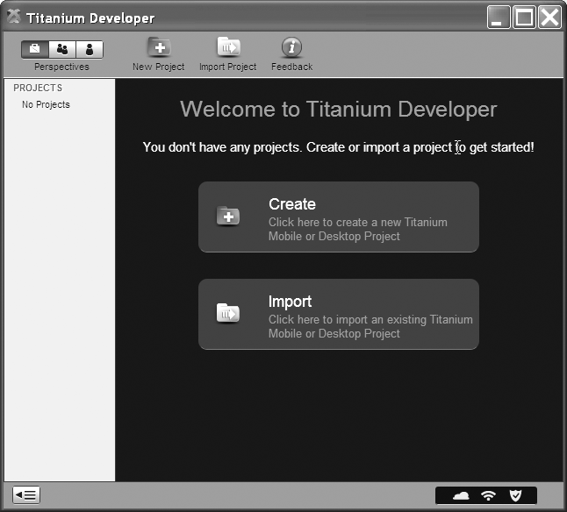
Figure 17–3. Titanium Developer after fresh installation
Warning: Please be aware of the differences in version numbers as you test this chapter. Titanium Developer is a fast-moving target. The version that is available when you try it out may not match the one we have tested with. The goal of this chapter is to give you a feel for the nature of development using Titanium. You will need to adjust material depending on the latest version of Titanium at the point of your development. At the time of this writing the version is 0.5.0.
In this section, we also want to familiarize you with the complete scope of the Titanium Developer IDE. However, in Figure 17–3, as we don’t have any projects yet, some of the menus are not available for us to describe the IDE fully. For now we are going to show you a screenshot of what the IDE will look like when you have one of these projects. This will allow us to introduce the IDE in a comprehensive manner. With at least one project in place, the IDE will look like Figure 17–4. This view is called the Project Perspective.
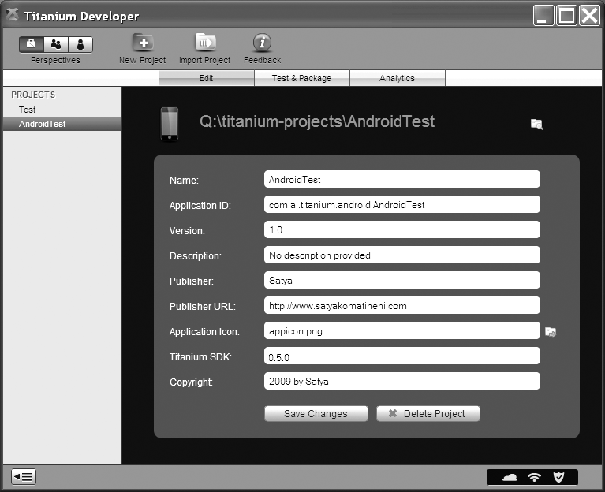
Figure 17–4. Titanium Developer Project Perspective
This Titanium Developer Project Perspective (Figure 17–4) has two project examples. You see the project names on the left-hand side. One is called Test and one is called AndroidTest. Test is a desktop application and AndroidTest is an Android Mobile application. You can use the same Titanium Developer IDE to develop both desktop and mobile applications.
An application (or project) like AndroidTest is essentially a directory on your local drive. For example, AndroidTest which is highlighted in Figure 17–4 is residing at c:\work\AndroidTest. The other parameters you see for this highlighted application are just attributes. One key attribute is the application ID which is going to be used for creating the root package for the Android Package file (.apk file).
Note: On some releases of Titanium Developer, “Desktop” is the default option. You won’t see “Mobile” as one of the options because the options are not in an option box but in an edit control. But if you click on the edit control that shows the application type as “Desktop” it will then open up the option dropdown that shows “Mobile”. But again, this may be corrected in your downloaded release of Titanium.
Once you have a project available, one option that you will use often is the Test & Package tab shown in Figure 17–5.
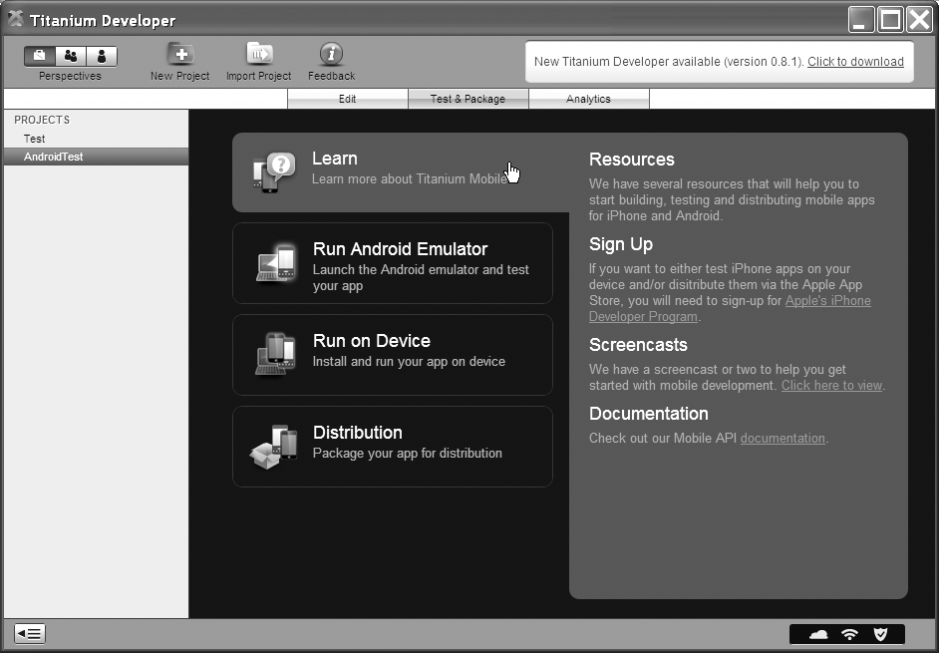
Figure 17–5. Titanium Developer Test & Package tab
This tab is responsible for taking your project resources and deploying them to the Android emulator for testing purposes. It also allows you to run on the device as well as prepare the Android application package for distribution purposes. This includes taking the package and installing it on a different emulator on a different development box or moving it to the Android marketplace or moving it to the Titanium App store. We will cover some of these later in the chapter.
Another nifty feature of the Titanium Developer tool is the Application store that you can browse for working applications. Here is the screenshot of this face of the tool (Figure 17–6). You can reach this screen by clicking on the Community perspective (the middle button in the top left-hand collection of buttons called “perspectives”). Once you are in the community perspective you will need to select the Apps tab.
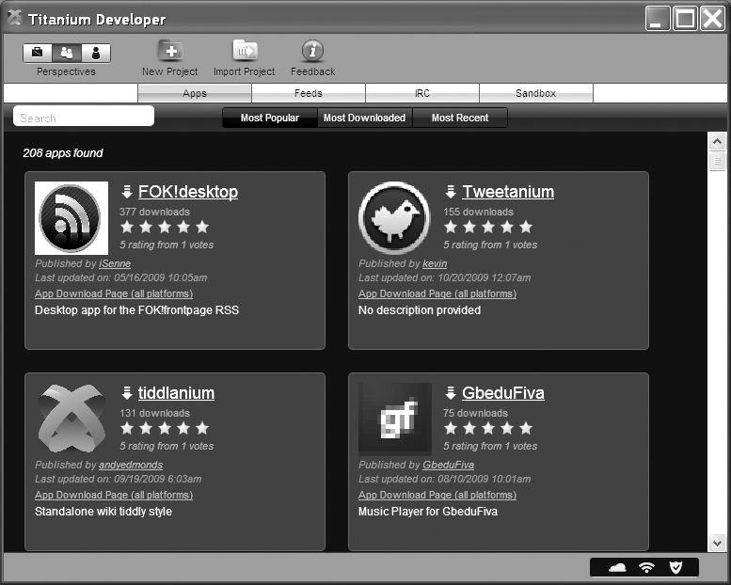
Figure 17–6. Titanium Developer Application or App store
The Titanium Developer also comes with a scratchpad (Figure 17–7) that you can quickly use to test sample code. You can reach this screen by going to the Community perspective again and choosing the Sandbox tab.
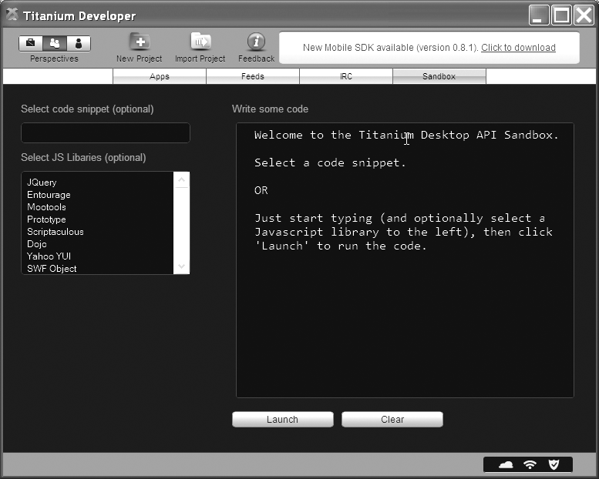
Figure 17–7. Titanium Developer Sandbox or scratchpad
A few things are evident in Figure 17–7. You can see that Titanium works in unison with a number of other tools such as JQuery and Mootools, which are displayed in the Select JS Libraries list box.
Note: These tools are also available as options when you create a new project. When you pick these tools, Titanium will copy the necessary JavaScript files to your Resource directory. Or you can download the necessary files yourself from these tools’ respective home pages.
The launch window of the Sandbox allows you to type any valid HTML or JavaScript and executes it. As an example, type the following HTML (Listing 17–2) and click on the launch button (shown in Figure 17–7).
Listing 17–2. Hello World for the Titanium IDE Scratchpad
<html><head></head>
<body>
<h2>Hello World</h2>
</body></html>
Listing 17–3 will show you a screen on your desktop with “Hello World” in it. You can then try adding some script to it as follows.
Listing 17–3. Hello World with JavaScript for the Titanium IDE Scratchpad
<html><head></head>
<body>
<h2>Hello World</h2>
<script>
alert('hello there');
</script>
</body></html>
When you launch using this HTML file, you will see the JavaScript alert “hello there” on your desktop HTML page. These examples are presented here to give you a feel for the underlying architecture of how HTML and JavaScript are orchestrated by Titanium Mobile.
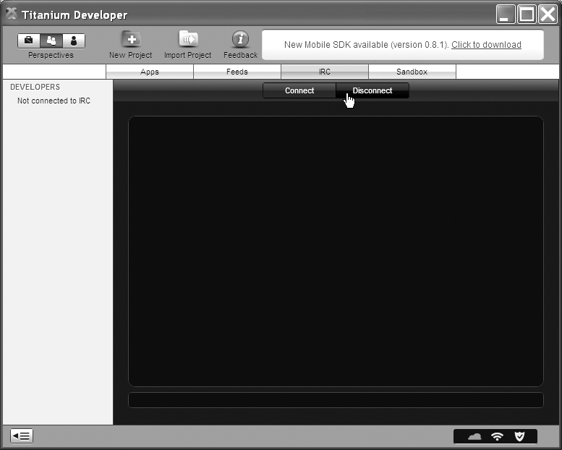
Figure 17–8. Titanium Developer IRC tab
Let us conclude this installation section by showing the IRC tab where you can interactively work with other online Titanium developers (see Figure 17–8). You can reach this screen by going to the Community perspective (middle button in the top-left corner) and then accessing the IRC tab. When you click the Connect button in this view you will see all the developers that are online in the left-hand portion of the screen.
Before moving on to the next section, let’s quickly review what we have covered so far. We have elaborated the architecture of Titanium Mobile, and showed you how Titanium Mobile allows you to program on a local device using HTML-related technologies, especially JavaScript. You learned how to download and install Titanium Mobile. We have also introduced the Titanium Mobile IDE and its features. This is fantastic background for the next section.

Getting to Know the Ropes: The First Project
Next, we will focus on the lifecycle of a typical Titanium Mobile project. We will show you how to create a project with default options and test that project on the emulator. We will then take this default project and change it, to introduce your own HTML content by displaying a “Hello World” application.
We will then walk you through a couple of techniques for provisioning your project for debugging purposes. You will then learn how to package this project as an .apk file. Finally you will see how to sign and deploy this .apk file in other emulator instances.
We’ll start with the first one of these: creating a simple project.

Creating a Titanium Mobile Project
You can create a new Titanium Mobile project by clicking the New Project icon (Figure 17–3) in the top row of the Titanium Mobile IDE. To create the project, you can use the properties shown in Figure 17–4. This will create a project on your local drive as shown in Listing 17–4.
Listing 17–4. Titanium Mobile Project Structure
c:\work\AndroidTest1
\build
\android\<eclipse like project structure>
\Resources
\android\appicon.png
\default.png
\<your files and sub directories go here>
\index.html
\index.css
\about.html
\manifest
\tiapp.xml
Depending on the release, you may have some additional files or fewer files. But you get the general idea of the project structure here. The key directory, as indicated in the “Architecture” section, is the Resources subdirectory. This is where you need to create the HTML files, CSS files, JavaScript files, and so forth. You can have as many subdirectories as you want from here underneath (from the resources subdirectory onward) to realize your application. This directory is very similar to a directory that you would use to manage a web site.
Outside of this directory, under the root, the key file is tiapp.xml. This file acts as the configuration file for the Titanium project that is created. In Listing 17–5 we’ll take a look at the tiapp.xml that gets generated by default when you create this project.
Listing 17–5. Example tiapp.xml
<?xml version="1.0" encoding="UTF-8"?>
<ti:app xmlns:ti="http://ti.appcelerator.org">
<id>com.ai.titanium.android.AndroidTest1</id>
<name>AndroidTest1</name>
<version>1.0</version>
<icon>appicon.png</icon>
<persistent-wifi>false</persistent-wifi>
<prerendered-icon>false</prerendered-icon>
<statusbar-style>opaque</statusbar-style>
<windows>
<window>
<id>initial</id>
<url>index.html</url>
<backgroundColor>#111</backgroundColor>
<icon>ti://featured</icon>
<barColor>#000</barColor>
<fullscreen>false</fullscreen>
</window>
<window>
<id>about</id>
<url>about.html</url>
<backgroundColor>#111</backgroundColor>
<icon>ti://top rated</icon>
<barColor>#000</barColor>
<fullscreen>false</fullscreen>
</window>
</windows>
</ti:app>
We’re primarily concerned with giving you a general introduction to Titanium development, so we won’t go into each of the xml tags in tiapp.xml. You can read more about them by visiting the appcelerator community web site at
http://www.appcelerator.com/community/
The following URL is also useful for getting started:
http://www.codestrong.com/timobile/guides/get_started/
We have highlighted the nodes that we intend to discuss here, however. The highlighted window tag defines how many HTML files we want the app to display in multiple tabs. In Listing 17–5 we have two windows, one pointing to index.html, and the second pointing to about.html.
With these files which the new project automatically created in place, you can turn to the Test&Package tab of the Titanium Developer (see Figure 17–5) and choose to run the project in the emulator.
When you run this newly created application it looks like the following in the emulator (Figure 17–9). You should see this application started on the emulator without explicitly starting it, just like the Eclipse ADT. If it doesn’t for some reason you can go to the Android menu and explicitly start it.
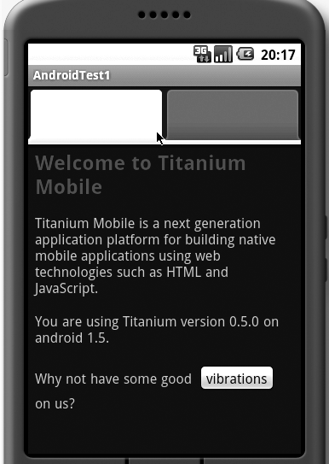
Figure 17–9. Titanium Developer multi-window sample application
If you take a look at the index.html and about.html you will see that index.html is populated into the first tab.

Crafting “Hello World”
Now let’s see how we can simplify this initial project by getting rid of the tabs and provide just one window. We’ll also change the background color to white so that the first page will look like the one shown in Figure 17–10.
We will need to do the following to make this happen:
- Provide a new index.html or change the existing index.html so that it looks like the page in Figure 17–10.
- Change tiapp.xml so that there is only one window and the url of the window is pointing to the index.html in step. Change the background color of the window to a light color.
We will walk through these steps now.
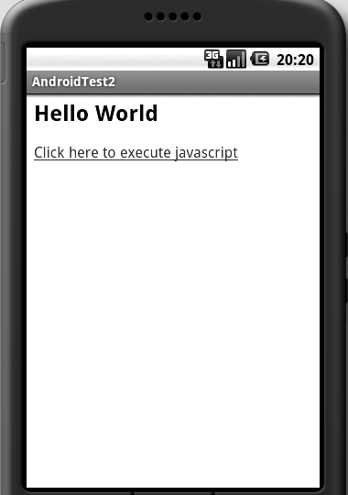
Figure 17–10. A Sample Android “Hello World”
The index.html that you will need to make this web page is shown in Listing 17–6. You can replace the index.html that was created for you by the IDE with this file.
Listing 17–6. Stand-alone “Hello World” Example
<html><body>
<h2>Hello World</h2>

<p><a href="javascript:alert('hello')">
Click here to execute JavaScript
</a></p>
</body></html>
This index.html is simple enough. The goal of this page is to call the JavaScript alert function to say hello when you click on the link that says click here to execute JavaScript.
Once this modified index.html is in place, let us see what you will need to change in the tiapp.xml. Here is the updated tiapp.xml. (Listing 17–7)
Listing 17–7. tiapp.xml with a Single Window
<?xml version="1.0" encoding="UTF-8"?>
<ti:app xmlns:ti="http://ti.appcelerator.org">
<id>com.ai.titanium.android.AndroidTest2</id>
<name>AndroidTest</name>
<version>1.0</version>
<icon>appicon.png</icon>
<persistent-wifi>false</persistent-wifi>
<prerendered-icon>false</prerendered-icon>
<statusbar-style>opaque</statusbar-style>
<windows>
<window>
<id>initial</id>
<url>index.html</url>
<backgroundColor>white</backgroundColor>
<icon>ti://featured</icon>
<barColor>#000</barColor>
<fullscreen>false</fullscreen>
</window>
</windows>
</ti:app>
The important elements are highlighted. Notice that there is only one window now pointing to the index.html and that its background color is stated as white.
Note: As you go through these examples, notice that we are incrementing the application title as AndroidTest1, AndroidTest2, etc. You don’t have to do it this way. We are doing this because we want to make it easier to get screenshots in a repeatable fashion. Otherwise, once we change the code we will lose the old test case. Hopefully, that is a minor distraction that you can follow.
With index.html and tiapp.xml in place, you can package and test this application in the emulator. When you run this application now through the Titanium Mobile IDE, you will see the Figure 17–10 in the Android emulator.

Provisioning the Application for Debugging
One of the reasons we have used an “alert” in the JavaScript in our index.html (Listing 17–6) is to test JavaScript to see if it is running. An alert is a good way to do this. In fact, many programmers use JavaScript alerts as a debugging tool.
However, you will notice that the JavaScript from the index.html (Listing 17–6) will just not say “hello” from the Android emulator. Yet, the same project, if you were to create it on the desktop, will readily say “hello.” What gives?
Apparently Appcelerator Inc. overrode this function to write the message to an internal debug console. As it turns out, WebKit, being the host of a web page (in this case the index.html) allows a client to configure what “alert” really means. On the Android platform Appcelerator chose to divert the message to a log stream instead of directing it to the console. We can only guess as to the motivations.
There are two possible motivations. In the JavaScript space, developers are increasingly using alert just as a way to debug. The argument goes that if an alert is used primarily as a debug tool, why not just log the message and not have the message show up on the screen as well? This unnecessary message will only distract the users from the real application. The second reason is the nature of Android. Dialogs in Android are asynchronous. So it will be pretty round-about to make that alert dialog wait, as that is what is expected by JavaScript.
There are two workarounds to this problem. The first is to use the Titanium UI API for creating a native Android alert dialog with an OK button. The second option is to use the Titanium Debug API. We will cover both here.
Listing 17–8 gives the example index.html rewritten to use both these options.
Listing 17–8. index.html That Uses Alternative Debug Options
<html><head>
<script>
function myalert(message)
{
var a = Titanium.UI.createAlertDialog();
a.setMessage(message);
a.setTitle('My Alert');
a.setButtonNames(["OK"]);
a.show();
}

function dalert(message)
{
Titanium.API.info(message);
alert(message);
//var a = prompt(message);
myalert(message);
}
</script>

</head>

<body>
<h2>Hello World</h2>

<p><a href="javascript:dalert('hello')">
Click here to execute JavaScript
</a></p>

</body></html>
The function myalert uses the Android dialog option. When this function is called, the screen will look like Figure 17–11. This works well, but you must be aware that native alert dialogs in Android are asynchronous and also need to be reference-counted for efficiency. So you may want to use them sparingly.
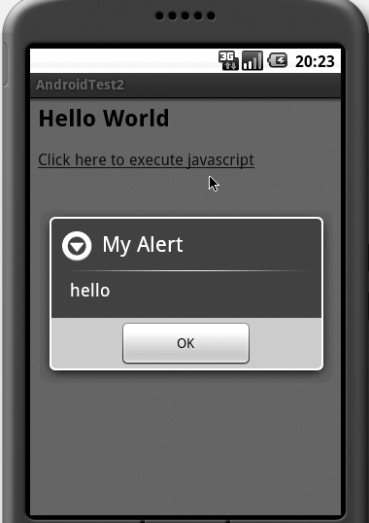
Figure 17–11. Titanium native alert window
The second option is to use the Titanium Debug API to log debug messages instead of alerts. This is demonstrated in the function dalert. These messages will go to the Titanium Mobile Console window. The console window is the window that gets shown when you use the launch tab. You will need to do the following to activate the launch tab.
- Choose the project name by clicking it in the project list.
- Click the Test & Package tab.
- Click the vertical Android emulator tab. This will show the console window on the right inside the IDE with two buttons at the bottom to “launch” and “stop emulator.”
- Click Launch App to run the app. When the app is running, the Titanium debug messages will show up in this right-hand console window.
Figure 17–12 shows an example.
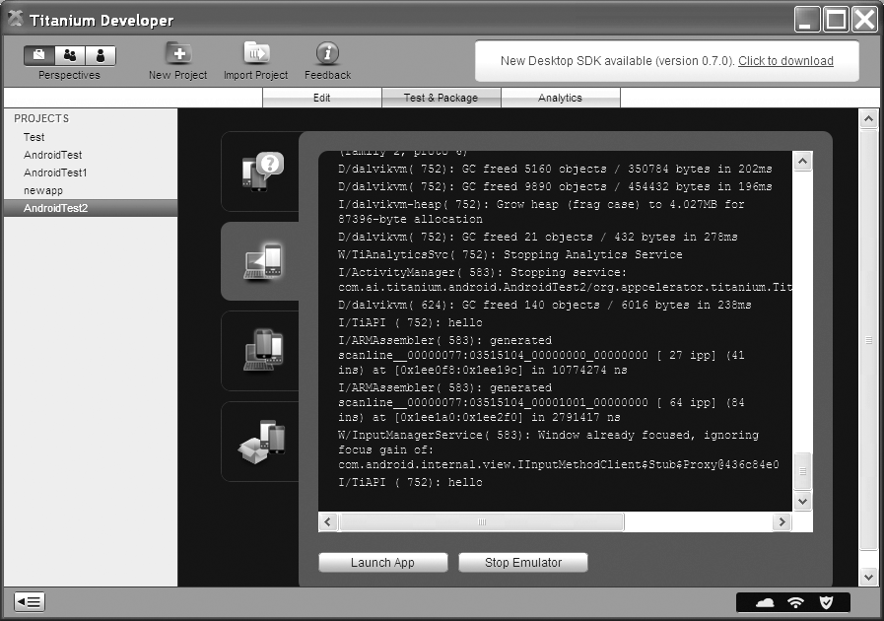
Figure 17–12. Titanium Titanium mobile console window
Notice the line in the middle of the screen that says I/TiApi: hello. This is the message we have sent through Titanium.API.info(message). (Interestingly, though, the “prompt” JavaScript function works fine.) If you are trying this for the first time, we want to mention this alert surprise which you may run into.
Now that we have an application and we know how to debug it, let us take this application and package it as an .apk file.

Packaging the Application
In Android, the unit of deployment is an Android package file called an .apk file. (You can refer to Chapter 7 for more details on how to work with .apk files.) You will need one of these .apk files to move your application to other places.
According to Android, an .apk file has to be signed in order to be deployed in an emulator or device or the marketplace. In fact, when you develop and test Android applications through the Eclipse ADT, the ADT is signing them (behind the scenes) with a built-in key that is only good for test deployment in the emulator. Android also treats the .apk files that are installed with the same signature a bit specially, where they share the process space.
Note: When two .apk files share the same process space they are sharing the JVM that makes up the process space. They can share common variables, but problems in one .apk file can affect the other .apk file as well.
This may be good or bad, depending on how much isolation you would like. The signature is also important for installing updates to that application.
For more information on signing the application please see Chapter 7. You can also read more at
http://developer.android.com/guide/publishing/app-signing.html
As a side note, Android keeps the debug or development time key stores at the following locations:
- For Mac OS X and Linux: ~/.android/debug.keystore
- For Windows XP: C:\Documents and Settings\\.android\debug.keystore
- For Windows Vista: C:\Users\\.android\debug.keystore
To sign an .apk file yourself you will need to understand the key infrastructure that is provided by the JDK (Java Development Kit). (We mentioned in Chapter 2 that to run Eclipse you will need to download a compatible JDK.) You will need to use the keytool from the JDK to create a key store with a password. (See Chapter 7, or consult http://java.sun.com/javase/6/docs/technotes/tools/windows/keytool.html for more information.) Listing 17–9 shows an example of creating a key store along with one key called mykey with /jre/bin/keytool:
Listing 17–9. keytool Options
keytool
-genkey //generate a public/private key
-alias mykey //name of the key
-keystore c:\somekeystore.store //location of a store
-storepass abc //password
-keypass abc //password
-keyalg RSA //key algorithm
-validaty 14000 //how many days is it valid
Once you have the key store created you can use the Distribution tab (see Figure 17–4 under Test & Packaging) to create an .apk file. Titanium Developer will prompt you for a key name to sign the package with. You will need to know the path to the key store and the key store password. If you don’t remember the key name (also called an alias) you can use the keytool to list the entries in the key store for you. But at a minimum you will need to write down and keep the key store location and password somewhere safe. Here is an example command that will list the contents of a key store:
keytool -list c:\somekeystore.store
Under the covers, Titanium uses jarsigner (covered in Chapter 7) to take the key alias you have specified and sign the .apk file. Titanium will then create the physical .apk file in the directory that you have specified.
It is worth noting here that the Eclipse ADT (also explained in Chapter 7) allows you to create an .apk file unsigned (you will then use the keytool and jarsigner to sign it yourself) but the Titaninum Developer uses only the signed approach for creating .apk files that can be run outside its environment.
For testing the application on the emulator, both Eclipse ADT and Titanium IDE sign the .apk files with a built-in key that is only good for test deployment in the emulator. In fact, we indicated earlier where these default keys are kept in the case of the Eclipse ADT. Titanium IDE maintains a similar store. However, you rarely need to know where these development keys are stored.

Installing the .apk File on Your Own Emulator
With the signed .apk file in your hand, you can proceed to install that file in an Android emulator that you normally use (as opposed to the emulator that Titanium uses) to test your other Android applications. To do this you will need to start the emulator by doing the following:
\android\tools\emulator @avdname
Here avdname is the name of your Android Virtual Device (AVD). (See Chapter 2 for a description of AVDsand how to create them.) This is a mechanism that allows you to run multiple emulators, each with its own level of Android SDK and tools for testing purposes. Creating an AVD is a bit complicated, but here is a quick command for doing so:
android create avd -t 3 -c 32M -p ..\avds\avd3 -n avd 3
Here –t is target Android SDK level, -c is memory, -p is the path, and avd3 is the name of the avd.
Once the emulator is up and running, you can use the commands in Listing 17–10 to install and uninstall that package.
Listing 17–10. adb Install and Uninstall Options
adb install [-l] [-r]
- push this package file to the device and instal it
('-l' means forward-lock the app)
('-r' means reinstall the app, keeping its data)

adb uninstall [-k]
- remove this app package from the device
('-k' means keep the data and cache directorie)
Notice how during the install you are using the file name and during the uninstall you are using the fully qualified java-like package name. For our AndroidTest2 application, the fully qualified package name will be
com.ai.android.titanium.AndroidTest2
You can also use the emulator or the device directly to uninstall any application. Here are the steps for that approach:
- Start the Emulator.
- From menu choose Dev Tools.
- Go to Package Browser and locate your package.
- Choose menu while highlighting the package name.
- Choose Delete Package from the menu options.
Again, to start the emulator you need the avd name. You can use the following two commands to help with this. The first one will list the available avds and the second one will start the emulator for a given avd.
\tools\android list avd // lists avds available
\tools\emulator @avdname // start a specific avd
Of course, after going through all this you will finally be able to run your app in the emulator of your choice. When you run the app in your emulator, what you see in the emulator will be the same as shown in Figure 17–10.
We will leave this section with another nifty thing you can do with your Titanium project. As part of the build, Titanium actually creates a subdirectory called android under the build subdirectory. This directory is actually a full-fledged Eclipse ADT project. All you have to do on Windows is move the tiapp.xml and the Resources subdirectory into the build/android/assets. Then the build/android subdirectory is complete and now you can test or develop further in the Android native environment under the Eclipse ADT. You may have to delete R.java if you see build errors.

Planning for Real-World Applications
The proposition so far in this chapter has been that with HTML or JavaScript we can write all our applications. But how practical is that? In any application you will need mechanisms to program a flexible UI with forms, media, and so forth. You will need something to host your business logic and you will need something to read and persist state in a database.
Let us talk about simpler things first: middleware and data. JavaScript through AJAX and JSON can always request data through servers which can act as conduits for persistence and also some or all business logic. If the application were to access some local resources or local databases they could always use SQLite. But you would expect that cloud services and the threetier model are better for all but special cases. You would foresee no significant problems with this approach.
A UI framework is a different beast, however. Frameworks like Swing and WPF (Windows Presentation Framework) are complex frameworks. How far can plain HTML combined with JavaScript match these UI capabilities?
Although a number of hurdles remain, a tool like JQuery that is based on JavaScript gives a powerful model to dynamically alter the HTML DOM tree to address some of these questions.
JQuery is nimble, simple, and extensible. The “query” in JQuery comes from its ability to query any node in an HTML DOM through succinct syntax like CSS selectors and XSLT expressions. So the query in JQuery does not indicate its affinity to being a database tool. It is in fact a UI tool for HTML. We will go through a few examples in this chapter to show you how this works.
JQuery is just one of the tools in this genre that use HTML and JavaScript for extensive UI programming. You are free to investigate these alternatives and choose an appropriate one for your needs.
With that said, let us take a quick tour of JQuery.

Essential Primer on JQuery
You can find the home page for JQuery at http://jquery.com/. From there you will be able to download the single JavaScript file that makes up JQuery. This file is about 100K of JavaScript. Once you download it, you will be able to include it in your HTML pages using the code segment in Listing 17–11.
Listing 17–11. Including JQuery in an HTML File
<script src="../../js/jquery132-dev.js"></script>
Overall, the documentation at the site is very good. This makes it easy to quickly learn JQuery. And you can leverage this knowledge in your serverside HTML programming
as well.
Let us see what we can do with it. One common thing you might want to do in HTML is to locate a div or a paragraph and replace the contents of that element with some text. You may also want to change the style of that div or hide that div. So let us do each of these (see Listing 17–12).
Listing 17–12. JQuery Selection Examples
function replaceAParagraph(newText)
{
//locate the HTML element with an ID
//it returns an array of matching elements
var myParagraph = $("#MyParagraphID")[0];

//read the old HTML from the element
var oldText = myParagraph.html();

//replace it with the new
myParagraph.html(newText);

//or simpler format
$("#MyParagraphID").html(newText);

//change the style of that element
$("#MyParagraphID").css("color:red;");

//hide the element
$("#MyParagraphID").hide();
}
The $ is a function that belongs to JQuery and uses selectors to locate the needed element. Its syntax for getting at an element is elaborate and forms the core of JQuery. Listing 17–13 shows some of the many ways of using a selector.
Listing 17–13. Various JQuery Selectors
$("#MyElementID") // A specific id
$(".MyClass") //all elements matching this class
$("p") // all paragraphs
$("p.MyClass") //paragraphs with MyClass
$("div") // all divs
$(".MyClass1.MyClass2.MyClass3") // locate three classes
$("div,p,p.MyClass,#MyElementID") //matching all those

//Immediate children
$("#Main > *") // All children of Main
$("parent > child")

//Children and grand children
$("ancestor descendents")
$("form input") // all input fields in a form

$("label + input") // all inputs next to a label
$("prev + next")

//starting at myclass find siblings of type div
$(".myclass ~ div")
$("prev ~ next)
Once a certain set of elements is selected using these selectors, you can filter the output nodes further by using the following filter syntax:
$("selector:criteria")
Here is how you use this selector and criteria syntax:
$("tr:even").css("background-color", "#bbbbff");
This example selects every row of a table which is an even row and then sets its style. Some of the possible criteria are shown in Listing 17–14.
Listing 17–14. JQuery Selection Criteria
first
last
even
odd
eq(index)
lt(index)
gt(index)
header //(h1, h2 etc)
animated
Listing 17–15 presents a few more examples taken from the JQuery documentation site and slightly changed to better format them.
Listing 17–15. Implementing hover over a Paragraph
function hoverParagraph()
{
$("p").hover(function () {
$(this).css({'background-color' : 'yellow', 'font-weight' : 'bolder'});
}, function () {
var cssObj = {
'background-color' : '#ddd',
'font-weight' : '',
'color' : 'rgb(0,40,244)'
}
$(this).css(cssObj);
});
}
This is an example in which a paragraph is located and a set of callback functions are registered for a hover action. The first function changes the CSS of the paragraph to use ayellow background and the font weight of bold. The second function changes it to a different CSS when the hover is off.
Listing 17–16 is an example of working with a mouseover.
Listing 17–16. Working with a Mouseover
function paragraphMouseover()
{
$("p").mouseover(function () {
$(this).css("color","red");
});
}
This is an example in which the CSS of a paragraph is changed with an anonymous function on a mouseover.

Essential Primer on Advanced JavaScript
As you start adapting JavaScript-centric technologies such as JQuery or Titanium (through its JavaScript API) you will start noticing JavaScript patterns that are quite unusual to someone that only uses JavaScript occasionally to supplement web pages.
The first of these surprises comes from the array and object equivalence. Let us lay this mystery out. We’ll start with an object declaration or initialization in JavaScript.
var myobj = {};
The curly braces in this context define the start and end of an object initialization. In this example we have nothing inside the curly braces. This tells JavaScript that myobj is an object with no content or members in it. However, this defines an object. Let us extend this initialization pattern:
var myobj = {name:"phone-number1",value:"123456"};
This statement allows you to do the following:
alert(myobj.name());
or
alert(myobj["name"]);
This proves the equivalence of associative arrays and objects, and goes to show that an object’s members are represented internally as an associative array. The converse is true too.
var myobj={};
myobj["name"] = "aaaa";
myobj["value"] = "bbbb";
The following two statements will be identical as well.
alert(myobj.name());
or
alert(myobj["name"]);
This sort of object initialization is pretty handy. Consider the following snippet, which we will use in a subsequent section (See isting 17–17.)
Listing 17–17. JavaScript Array Definition Example
var itemArray = [
{name: "Social", value: "12345678"},
{name: "cell1", value: "12345678"},
{name: "cell2", value: "12345678"}
];
This quickly defines an array of three objects, each holding a name/value pair as their fields. The object initialization pattern allows nested objects as well. Here is an example (Listing 17–18).
Listing 17–18. Nested Object Initialization
var someobj = {field1:10,
field2:"string",
field3:{field1:10,field2:"string"));
This essentially forms the basis of JSON (JavaScript Object Notation). Data that is in the form of JSON is often used as a communication mechanism between clients and servers. If you are not familiar with the idea you may want to read up on JSON (http://json.org) as you will want to use something like this to communicate with web servers to retrieve or save data over HTTP.
Let us now talk briefly about anonymous functions. Consider the following example (Listing 17–19).
Listing 17–19. Anonymous Functions
function Person() {
var age = 40; //init value
this.setAge = function(howold) { age = howold };
this.firstname = "First";
this.lastname = "Last";
}

var me = new Person();
me.firstname = "aaaa";
me.lastname = "bbbb";
me.setAge(25);
//the following will be wrong
me.age=44;
In the example above, the member setAge is defined as an anonymous function with access to the private variable age, whereas the firstname and lastname are public variables.
We will conclude this section with a discussion of JavaScript namespaces, as they are used quite a bit in JavaScript-based libraries.
Consider the following pattern (Listing 17–20), which is often quoted as an approach to maintain namespaces in JavaScript.
Listing 17–20. JavaScript Namespaces
var MY_NAME_SPACE = function() {
return {
method_1 : function() {
// do stuff here
},
method_2 : function() {
// do stuff here
}
};
}();
It is quite revealing to understand this type of JavaScript coding pattern. At a high level the above code allows you to do the following:
MY_NAME_SPACE.method_1();
MY_NAME_SPACE.method_2();
The MY_NAME_SPACE prefix will prevent the author from conflicting with other libraries. But let us understand what is happening. We’ll start with the returnstatement. If you see the pattern
var someobj = {method_1: function() {}, method_2: function2() {}}
this is essentially an object initialization where the object has two members, method_1 and method_2, and each is an anonymous function. So if this is an object, then the above statement is
var MY_NAME_SPACE = function() { return someobj; }();
where the someobj happens to be an object with functions method1 and method2. Now without the trailing (), MY_NAME_SPACE would have been a function and not an object like someobj with methods in it. And we need someobj so that we can do someobj.method1(). The trailing () essentially executes the anonymous function and makes MY_NAME_SPACE point to the someobj that is returned as a result. That is how we are able to do this:
MY_NAME_SPACE.method_1();
MY_NAME_SPACE.method_2();
Sometimes you will see this pattern written as follows:
var MY_NAME_SPACE = (function() {
return {
method_1 : function() {
// do stuff here
},
method_2 : function() {
// do stuff here
}
};
})();

Understanding the Microtemplating Engine
As soon as you start programming HTML as if it is a UI framework, you will quickly realize you could benefit from a templating engine used in technologies like JSP or ASP. Consider the following JavaScript array, for example:
var itemAarray = [
{name: "Social", value: "12345678"},
{name: "cell1", value: "12345678"},
{name: "cell2", value: "12345678"}
];
Say you want to create an HTML page that looks like this:
Social
12345678
Cell1
12345678
Cell2
12345678
It is really painful, even with the convenience of a Jquery, to create all those HTML nodes on the fly. Instead you would want to use a template that looks like a typical JSP page as shown in Listing 17–21:
Listing 17–21. Example HTML Template
<#
for(var i=0; i < itemArrayData.length; i++)
{
var item = itemArrayData[i];
#>
<p><#=item.name #>:<#=item.value #></p>
<# } #>
where the <%= of JSP is replaced with <#. To expand this template against the above JavaScript data set you will need some kind of a template engine that can be executed in JavaScript. John Resig, the author of JQuery, wrote one such templating engine. Due to its “tininess” it came to be called The JavaScript Microtemplating Engine.
Listing 17–22 shows the complete source code (as provided by John Resig, originally and subsequently altered on the Web by a number of folks), which you can save in a file for inclusion:
Listing 17–22. John Resig’s Code for Microtemplating Engine
var _tmplCache = {}
this.parseTemplate = function(str, data) {
/// <summary>
/// Client side template parser that uses <#= #> and <# code #> expressions.
/// and # # code blocks for template expansion.
/// NOTE: chokes on single quotes in the document in some situations
/// use ’ for literals in text and avoid any single quote
/// attribute delimiters.
/// </summary>
/// <param name="str" type="string">The text of the template to expand</param>
/// <param name="data" type="var">
/// Any data that is to be merged. Pass an object and
/// that object's properties are visible as variables.
/// </param>
/// <returns type="string" />
var err = "";
try {
var func = _tmplCache[str];
if (!func) {
var strFunc =
"var p=[],print=function(){p.push.apply(p,arguments);};" +
"with(obj){p.push('" +
// str
// .replace(/[\r\t\n]/g, " ")
// .split("<#").join("\t")
// .replace(/((^|#>)[^\t]*)'/g, "$1\r")
// .replace(/\t=(.*?)#>/g, "',$1,'")
// .split("\t").join("');")
// .split("#>").join("p.push('")
// .split("\r").join("\\'") + "');}return p.join('');";

str.replace(/[\r\t\n]/g, " ")
.replace(/'(?=[^#]*#>)/g, "\t")
.split("'").join("\\'")
.split("\t").join("'")
.replace(/<#=(.+?)#>/g, "',$1,'")
.split("<#").join("');")
.split("#>").join("p.push('")
+ "');}return p.join('');";

//alert(strFunc);
func = new Function("obj", strFunc);
_tmplCache[str] = func;
}
return func(data);
} catch (e) { err = e.message; }
return "< # ERROR: " + err.htmlEncode() + " # >";
}
Let us now show you an index.html that uses the concepts discussed so far and takes that object array and generates an HTML representation (see Listing 17–23). You will need to either download and include the jquery.js from the Jquery web site or use the one that came with Titanium. If you want to use the one that came with Titanium you will need to choose it when you create the project for the list of tools. (We found it easier to download it from the Jquery site. If you miss that step during project creation, you won’t have the option of choosing it later.) You will also need to create the template-engine.js using the code above and place it in an appropriate subdirectory of the Resources.
Listing 17–23. HTML Utilizing Microtemplating Engine
<html><head>
<script src="../../js/jquery132-dev.js"></script>
<script src="../../js/template-engine.js"></script>

<script>
//Data
var itemArray = [
{name: "Social", value: "12345678"},
{name: "cell1", value: "12345678"},
{name: "cell2", value: "12345678"}
];

function onloadFunction()
{
var s = $("#MyTemplate").html();
var s1 = parseTemplate(s, {itemArrayData: itemArray});
$("#target").html(s1);
}
</script>

<script id="MyTemplate" type="text/html">
<#
for(var i=0; i < itemArrayData.length; i++)
{
var item = itemArrayData[i];
#>
<p><#=item.name #>:<#=item.value #></p>
<# } #>
</script>

</head>

<body onload="onloadFunction()">
<div id="target">
<p>target</p>
</div>
</body></html>
Here is what this code does. In the body of the HTML it defines a div with an ID of target. On document load the function onLoadFunction() runs the template against the data using the parsetemplate() method. It uses the jQuery selectors to first locate the template, which is anchored as a script element with the ID MyTemplate. The output from the parse template will be an expanded string. This string will then be inserted into the div as inner HTML. Again we use the jQuery selector to locate the target div.
If you make this the index.html in your previous project and test it, you will see a screen that looks like Figure 17–13 in your emulator.
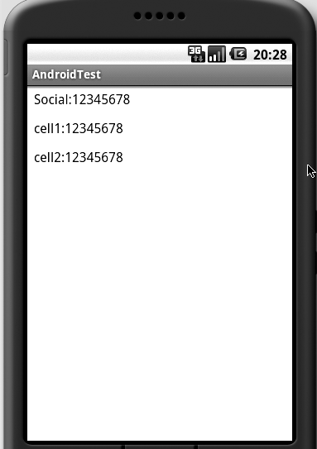
Figure 17–13. Micro Templating Engine in Android
That concludes our search for a tool that we can use effectively to craft complex HTML applications. JQuery has far more capabilities than this simple example demonstrates, but we have shown you some of the possibilities. There is also some additional work going on towards JQuery UI on the Internet which you may want to check out. A number of JavaScript programmers we have talked to also speak highly of Aptana Studio, which is based on Eclipse and offers many code development features for JavaScript.
Let us conclude this topic by briefly discussing Titanium-specific JavaScript API wrappers.

Additional Titanium Mobile APIs
Titanium Mobile supports a number of additional APIs to work with the native platform. You can discover these at http://www.codestrong.com/timobile/api/. We mention some of them briefly in Table 17–1.
Table 17–1. Titanium APIs for Android
Namespace | Contents
API | Has all the logging methods.
Accelerometer | Has the ability to listen and respond to accelerometer events.
App | You can get your project’s properties here at runtime.
Database | Allows you to execute and work with SQLite database.
Filesystem | Has the ability to work with local files and directories.
Geolocation | Gets lat longs and watches for a certain location.
Gesture | Works with portrait, landscape views.
Media | Has the ability to work with images, sounds, videos.
Network | Basic networking stack around httpclient.
Platform | You can work with things such as phone number, model, name, version, etc.
UI | Includes dialogs, menus, tables.

Summary
We have covered a lot of ground and presented a very innovative approach to supplement your programming toolkit for Android. This WebKit-based approach can supplement the Android framework in a number of ways. It promotes quick development due to the easier layout semantics of HTML (for example, scrolling is so natural to HTML that you don’t even need to think about it). The resulting UI can be easily styled with CSS. This approach also has a significant cross-platform appeal, which will open doors for web developers to be more productive on mobile platforms. Finally, the progress that is being made on the UI side for web frameworks is bound to spill over and enrich this programming experience further with the introduction of HTML5.
We have given you a lot of information in this chapter to understand the implications and architecture of WebKit-based technology and discover how suitable it is to your needs. This is a fun technology to program in. Tool sets involved are widely popular. Moreover, there’s a lot of documentation available on the Internet. All these factors should make Titanium an attractive alternative to use on Android.

